Improving Multi-class Text Classification Accuracy Using Fuzzy Logic and NLP Technique

A DISSERTATION SUBMITTED TO MANCHESTER METROPOLITAN

UNIVERSITY FOR THE DEGREE OF MASTER OF DATA SCIENCE

IN THE FACULTY OF SCIENCE AND ENGINEERING



September 2025

Author: Supervisor:

Afolakemi Mariam Kazeem Dr. Naomi Adel

# Abstract

Transformer-based models such as BERT have achieved state-of-the-art results in text classification, yet they remain vulnerable to the ambiguity inherent in human language. Their reliance on strict probabilistic logic makes them prone to performance drops when faced with overlapping categories or uncertain meanings. This research examined whether the integration of fuzzy logic, a paradigm explicitly designed to handle uncertainty, could alleviate this weakness. A hybrid classifier was developed that combined a fine-tuned BERT model with a knowledge-based fuzzy inference system applied to its softmax outputs. The system was evaluated against both the baseline BERT model and a human-annotated benchmark using the 20 Newsgroups dataset.

The results ran counter to the original hypothesis. The fuzzy-hybrid model performed significantly worse than the baseline, with McNemar’s test confirming the difference as statistically significant (p < 0.001). The analysis showed that a single, handcrafted fuzzy rule was too simplistic to address the complex error patterns produced by the deep learning model, and in practice introduced new errors. This outcome offers an important caution for research in eXplainable AI (XAI): adding simple, interpretable rules on top of opaque models does not guarantee improvement and can, in fact, compromise reliability. The study concludes that genuinely trustworthy AI will require deeper integration of uncertainty-aware reasoning at the architectural level, rather than superficial post-hoc adjustments.

##### 

# 

# Declaration

I declare that this dissertation is my own unaided work, submitted in partial fulfilment of the requirements for the degree of Master of Science in Data Science at Manchester Metropolitan University.

No part of this work has been submitted for any other degree or qualification at this or any other institution of learning. Where the ideas or work of others have been used, they have been properly acknowledged in the text and the list of references.

All research involving human participants was carried out in line with the University’s Academic Ethical Framework and received full ethical approval.

**EthOS Approval Number:** **79610**

# 

# Table of Contents

**Abstract 1**

**Declaration 2**

**Table of Contents 3**

**List of Figures 6**

**List of Tables 7**

**Chapter 1: Introduction 8**

1.1 Background and Motivation 8

1.2 Problem Statement 8

1.3 Aim and Objectives 9

1.4 Contribution to Knowledge 9

1.5 Dissertation Structure 10

**Chapter 2 - Literature Review 11**

2.1 Introduction 11

2.2 The Evolution of Text Classification: From Word Counts to Contextual Understanding 11

2.2.1 Traditional Approaches and Their Contextual Blindness 11

2.2.2 The Deep Learning Shift: Learning Features Automatically 13

2.2.3 The Transformer Era: State-of-the-Art Contextual Models 15

2.3 An Alternative Paradigm: Reasoning with Imprecision using Fuzzy Logic 17

2.4 Bridging the Paradigms: A Critical Review of Hybrid Fuzzy-NLP Models 19

2.4.1 Early Approaches: Fuzzy Reasoning on Traditional Features 20

2.4.2 Two-Stage Architectures: Fuzzy Logic at the Output Layer 20

2.4.3 Towards Deeper Integration: Word Embeddings, Ontologies, and Semantic Reasoning 20

2.5 Synthesis and Identification of the Research Gap 21

**Chapter 3 - Methodology 24**

3.1 Research Philosophy and Approach 24

3.2 Research Design 25

3.3 Dataset and Preprocessing 25

3.3.1 Dataset Selection and Justification 25

3.3.2 Data Preprocessing and Partitioning 26

3.4 Computational Modelling 27

3.4.1 Baseline Model: Standard BERT Classifier 27

3.4.2 Hybrid Model: Fuzzy-Augmented BERT Classifier 27

3.5 Human-Centred Study Design 28

3.5.1 Phase 1: Human Annotation and Agreement Analysis 28

3.5.2 Phase 2: Qualitative and Usability Evaluation 29

3.6 Evaluation Metrics and Strategy 30

3.6.1 Quantitative Performance Metrics 30

3.6.2 Qualitative and Usability Evaluation 31

3.7 Potential Challenges and Mitigation 31

3.8 Qualitative and Usability Evaluation 32

**Chapter 4: System Implementation 33**

4.1 Implementation Overview 33

4.2 The Experimental Pipeline 34

4.2.1 The Experiment Runner 34

4.2.2 The Evaluation Module 34

4.3 Baseline Model Implementation (BaselineBertClassifier) 35

4.4 Hybrid Model Implementation (FuzzyBertClassifier) 36

**Chapter 5: Results and Analysis 39**

5.1 Introduction 39

5.2 Quantitative Performance Comparison 39

5.3 Error Analysis via Confusion Matrix 40

5.4 Human Annotation Analysis: Inter-Annotator Agreement and Ambiguity Analysis 42

5.5 Focused Evaluation on Ambiguous Subset 43

5.5.1 Rationale for Focused Analysis 43

5.5.2 Results of Focused Evaluation 44

5.5.3 Analysis and Discussion 44

5.6 Usability Evaluation 45

5.6.1 Methodology 45

5.6.2 Results 45

5.6.3 Analysis 46

**Chapter 6: Discussion 47**

6.1 Revisiting the Research Problem 47

6.2 The Brittleness of State-of-the-Art Models in the Face of Ambiguity 47

6.3 The Failure of a Simple Corrective Rule: An Insight for eXplainable AI (XAI) 48

6.4 User Experience, Trust, and the Primacy of Accuracy 49

6.5 Synthesis and Implications 49

**Chapter 7: Conclusion 51**

7.1 Summary of the Research 51

7.2 Principal Findings 51

7.3 Limitations of the Study 52

7.4 Directions for Future Research 52

**Appendix 53**

Appendix A: Supporting Code and Materials. 53

Appendix B: Fuzzy Inference System Rule Base 54

B.1 Knowledge-Based Correction Rule 54

B.2 Default Fallback Rules 54

**References 56**

# 

# 

# List of Figures

**Fig 2.1: Overall Structure of the CNN** **14**

**Fig 2.2: Visualization of LSTM Memory Modules and Temporal Unrolling** **15**

**Fig 2.3: Transformer Structure Showing Encoder-Decoder Attention Flow** **16**

**Fig 2.4: Fuzzy Inference System for Ambiguous Text Classification** **19**

**Fig 2.5: Visual Representation of the Research Gap** **23**

**Fig 3.1: A flowchart showing the output of the BaselineBertClassifier** **28**

**Fig 4.1: Project Directory Structure** **33**

**Fig 4.2: A high-level diagram illustrating the architecture of the baseline BERT model** **36**

**Fig 4.3: Membership Functions for Input Probability** **37**

**Fig 4.4: A flowchart illustrating the architecture of the hybrid model** **38**

**Fig 5.1: Confusion Matrix for the Baseline BERT Model** **41**

**Fig 5.2: Confusion Matrix for the Fuzzy-Enhanced Model** **42**

**Figure A.1: Python function for preprocessing the 20 Newsgroups dataset** **53**

# 

# List of Tables

**Table 2.1: Comparison of Text Classification Approaches****22**

**Table 4.1: Example of an Intelligent Fuzzy Rule****38**

**Table 5.1: Summary of Model Performance Metrics on the Test Set****39**

**Table 5.2: McNemar's Test Contingency Table for Baseline vs. Hybrid Model Predictions****40**

**Table 5.3: Summary of Inter-Annotator Agreement Analysis****43**

**Table 5.4: Model Performance on 50-Document Ambiguous Subset vs. Human Consensus****44**

**Table 5.5: Average System Usability Scale (SUS) Scores****46**

# 

# Chapter 1: Introduction

## **1.1 Background and Motivation**

In today’s information-rich world, the ability to automatically interpret large volumes of text is no longer a specialised task. It has become a basic requirement across industries. Text classification, which involves sorting text into predefined categories, plays a central role in real-world systems like email filtering, customer service bots, and sentiment tracking. Recent breakthroughs in Natural Language Processing (NLP), particularly the emergence of Transformer-based models, have significantly enhanced our ability to capture meaning and context in language.

Yet, despite their impressive capabilities, these models often struggle with one of language’s most fundamental traits: 'ambiguity’. This challenge becomes especially critical in sensitive fields where small improvements in accuracy and interpretability can lead to meaningful impact. Take clinical trials for example, NLP tools used during the patient recruitment process can help identify suitable candidates by scanning medical records. Even modest gains in classification accuracy can save time and resources. Studies have shown that improving efficiency in this step can cut manual review workloads by over 40 percent, ultimately accelerating trial timelines and reducing costs (Carlisle et al., 2021). In such contexts, it is not enough for a model to be merely accurate. It must also be capable of handling the subtleties and uncertainties in human writing.

This project explores the potential of bridging two complementary approaches: the contextual strength of deep learning and the interpretive flexibility of fuzzy logic. By combining these methods, the research aims to build a more robust text classification system. One that not only performs well on structured input but also maintains reliability in the face of linguistic ambiguity. At its core, the project is founded on the idea that embracing uncertainty through “degrees of truth” can lead to models that are both smarter and more trustworthy.

## **1.2 Problem Statement**

While deep learning models have shown excellent results in standard classification tasks, their performance tends to drop in situations where linguistic ambiguity is present. Human language is inherently vague; words often carry multiple meanings, and sentence interpretation can depend heavily on subtle context. Existing models typically resolve this uncertainty by assigning a single, crisp label even when the input could reasonably fit more than one category. This binary decision-making approach does not reflect the way humans process meaning. As a result, outputs can appear confident but misleading, especially in complex or overlapping categories. For example, a news article discussing the ethics of space medicine could reasonably be classified under both *sci.med* and *talk.politics.mideast*, creating uncertainty that crisp models often fail to resolve (Radovanović and Ivanović, 2008).

This project asks: *Can integrating fuzzy reasoning directly into the semantic feature space of deep learning models lead to more accurate and interpretable text classification?*

## 

## **1.3 Aim and Objectives**

The primary aim of this study is to explore, design, and validate an innovative hybrid classification model that incorporates fuzzy logic at the feature level within a Transformer-based NLP framework. This approach is intended to offer a more effective means of addressing the ambiguity that naturally arises in human language.

To fulfil this aim, the project is guided by the following objectives:

* To carry out a structured review of the academic literature on text classification, tracing developments from early machine learning approaches through to modern Transformer-based models, while critically examining how fuzzy logic has been applied within NLP systems.
* To design and carry out a human annotation study, in which participants label text samples containing ambiguous content. These annotations will serve as a gold standard against which both standard and fuzzy-augmented models can be evaluated.
* To implement and fine-tune a standard Transformer-based model such as BERT to establish a strong computational benchmark for comparison.
* To design and build a hybrid classification model that embeds a fuzzy inference mechanism directly into the contextual representations produced by the Transformer, enabling more nuanced reasoning.
* To evaluate and compare the baseline and hybrid models against the human-labeled benchmark using established performance metrics, including Accuracy, Precision, Recall, and F1-Score.
* To analyse the findings with a focus on both performance and usability, reflecting on the ethical and professional responsibilities involved in building transparent, trustworthy AI systems.

## 1.4 Contribution to Knowledge

This research makes two key contributions to the field of automated text classification, both in terms of model development and evaluation methodology.

* **A New Hybrid Architecture Integrating Fuzzy Reasoning:**

The main technical contribution lies in the development of a hybrid classification model that embeds fuzzy logic within the contextual feature space of a Transformer-based architecture. Unlike prior approaches that rely on fuzzy logic only at the output stage, this model integrates fuzzy reasoning earlier in the pipeline at the feature level where ambiguity is most prevalent. By doing so, it enables the classifier to address uncertainty directly within the semantic representation of text, marking a notable advance in the design of robust and ambiguity-aware NLP systems.

* **Empirical Evaluation Anchored in Human Judgement:**

A second key contribution is the development of a dual evaluation strategy that combines statistical model metrics with insights from human annotators. By comparing machine predictions to participant judgments on ambiguous texts, this study offers a more nuanced assessment of how well the system aligns with human reasoning. This approach strengthens the interpretability claim and supports a more user-centred evaluation of classification outcomes, this provides a necessary bridge between statistical performance and real-world applicability, a connection often missing in purely technical evaluations.

## 1.5 Dissertation Structure

This dissertation is structured across six chapters, each building upon the last to guide the reader through the rationale, implementation, and evaluation of the study.

* **Chapter 2** provides a critical review of the relevant academic literature. It lays the theoretical groundwork for both text classification and fuzzy logic, and highlights the specific gap in current research that this project aims to fill.
* **Chapter 3** outlines the methodological approach used in the study. This includes the design of the human-led annotation experiment, the structure and implementation of the computational models, the dataset selection and preparation process, and the overall strategy for evaluating model performance.
* **Chapter 4** presents the results of the study, including both quantitative metrics and qualitative insights. A comparative analysis is provided to evaluate the performance of the baseline and hybrid models.
* **Chapter 5** discusses the findings in depth, interpreting their significance in light of the research objectives and the broader body of existing work.
* **Chapter 6** concludes the dissertation by summarising the main contributions of the project, acknowledging its limitations, and offering suggestions for future research directions.

# Chapter 2 - Literature Review

## 2.1 Introduction

Automated text classification plays a central role in Natural Language Processing (NLP), forming the basis of many real-world applications from filtering emails and categorising news articles to monitoring public sentiment. Although the field has advanced considerably in recent years, a persistent challenge remains, the inherent ambiguity of human language. Words often carry multiple meanings, the interpretation of sentences can shift depending on subtle cues, and the lines dividing semantic categories are rarely clear-cut. This complexity continues to pose difficulties for even the most advanced systems.

This chapter offers a critical overview of the field, gradually narrowing its focus from the general problem of ambiguity to the specific gap this project aims to address. It begins with a discussion of traditional machine learning techniques and their constraints, then moves on to examine how deep learning, particularly Transformer-based models, has enabled more sophisticated, context-aware classification. The chapter then introduces fuzzy logic as a complementary approach, well-suited to reasoning in situations where uncertainty and vagueness are unavoidable.

By critically evaluating existing efforts to combine these two domains, it becomes clear that a key opportunity remains unexplored, the integration of fuzzy reasoning directly within the deep semantic representations produced by modern NLP architectures. This unaddressed challenge forms the foundation of the hybrid model proposed and developed in this study.

## 2.2 The Evolution of Text Classification: From Word Counts to Contextual Understanding

The development of text classification reflects a gradual evolution toward a deeper understanding of language. While early methods established a solid foundation, their limitations prompted the emergence of more advanced techniques that aim to mirror how humans interpret meaning in text.

### 2.2.1 Traditional Approaches and Their Contextual Blindness

In the early stages of text classification research, classical machine learning algorithms played a dominant role. These approaches typically relied on the **bag-of-words model**, which transforms text into a numerical vector by counting the frequency of each word within a document (Radovanović and Ivanović, 2008). While this method is straightforward, it treats all words as independent and ignores grammar or word order.

To make these representations more meaningful, weighting schemes such as Term Frequency-Inverse Document Frequency (TF-IDF) were commonly used. TF-IDF helps emphasize words that are unique to a document while downplaying those that are frequent across many texts. Algorithms like Support Vector Machines (SVM), Naive Bayes, and Logistic Regression were widely used with these features due to their simplicity, speed, and relatively good performance on many classification tasks (Manning, Raghavan, and Schütze, 2008). However, while effective to a point, these methods often struggle with capturing deeper meanings, such as sarcasm, negation, or the relationship between words, limitations that newer techniques have tried to overcome.

A closer examination of traditional classification algorithms reveals specific limitations in handling linguistic ambiguity. Support Vector Machines (SVM), for example, are designed to find an optimal hyperplane that separates data points into distinct categories. While they perform well with linearly separable data and can be extended to more complex scenarios using kernel functions, SVMs are fundamentally constrained by their reliance on a single, hard decision boundary. This makes them ill-suited for cases where documents exhibit overlapping characteristics, such as when a text belongs partially to multiple categories (Manning, Raghavan, and Schütze, 2008). Such nuanced scenarios challenge the binary nature of the model’s predictions.

Naïve Bayes (NB) classifiers, although appealing for their simplicity and computational speed, are built on the assumption of conditional independence among features. As noted by Salloum et al., this means the model treats the occurrence of terms like "engine" and "software" as entirely unrelated, missing the semantic connections that a human would readily recognize. While NB classifiers can perform well as a baseline, this inability to model interactions between features significantly limits their capacity to interpret language in context. These shortcomings underscore the need for models that can learn both individual features and the relationships between them directly from the data.

A systematic review of NLP-based classification techniques highlights several traditional algorithms that have long been staples in the field. Among the most commonly used is:

* **Support Vector Machines (SVM):** Known for its ability to find the optimal boundary (or hyperplane) that separates different categories of text. Its strong performance and solid mathematical foundation have made it a go-to choice for many classification problems.
* **Naïve Bayes (NB)**: Despite being based on the simplifying assumption that words in a document are independent of one another, has remained surprisingly competitive. Its simplicity, speed, and consistent results make it a frequent baseline in comparative studies (Salloum et al., 2022).
* **Decision Trees (DT)** and **Random Forests (RF)** have also been widely applied. These models operate by making decisions through a series of branching conditions. Random Forest, in particular, improves on basic decision trees by combining the outputs of many trees to increase accuracy and reduce overfitting.

While dependable, these methods share a critical limitation: an inability to capture the contextual relationships that are essential for resolving linguistic ambiguity.

### 2.2.2 The Deep Learning Shift: Learning Features Automatically

The rise of deep learning brought a fundamental change to natural language processing by allowing models to move beyond simple word frequency counts and instead learn meaningful, context-aware features directly from data. This shift significantly improved classification performance and reduced the reliance on manual feature engineering. As a result, several neural network architectures have become central components of modern NLP pipelines (Zheng, Xu, and Wang, 2022).

* **Convolutional Neural Networks (CNNs) for Text**

Although Convolutional Neural Networks (CNNs) were originally designed for tasks like image recognition, researchers soon discovered they could be adapted effectively for analysing text. In the context of NLP, a CNN processes a sentence much like it would process an image treating each word embedding as a row in a matrix.

The key idea is to apply convolutional filters across this matrix to detect local patterns in the text, such as key phrases or combinations of words (n-grams), no matter where they appear in the sentence. These patterns are often strong indicators of meaning or intent. Once identified, the model uses a pooling layer to extract and summarise the most relevant features, reducing noise and complexity. The final step involves feeding these distilled features into a classification layer, which produces the output category.

This approach is particularly effective for short texts where the presence or absence of certain phrases is critical, and it has become a valuable tool in modern NLP pipelines (Es-Sabery, Ennaji and Kabbaj, 2021).

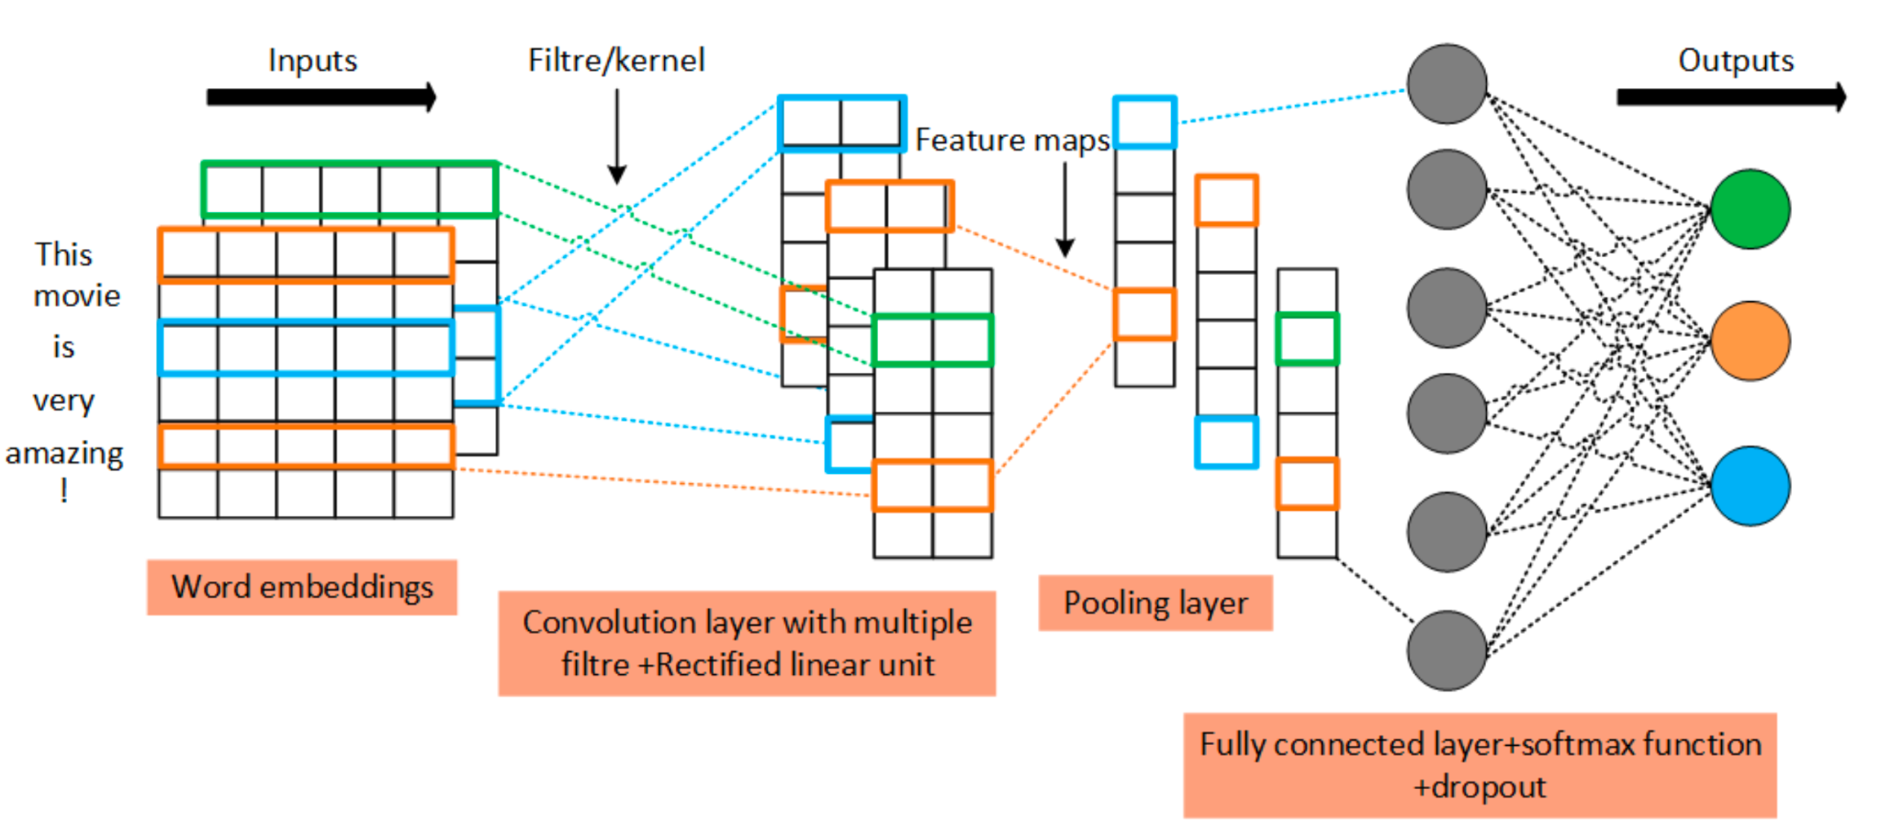

*Fig 2.1: Overall Structure of the CNN*

* **Recurrent Neural Networks (RNNs) and LSTM**

In contrast to CNNs, which focus on detecting spatial patterns, Recurrent Neural Networks (RNNs) are specifically built to work with sequential data, making them particularly well-suited to natural language tasks. An RNN processes text one word at a time, passing information from one step to the next through a hidden state effectively maintaining a form of memory that captures what has come before in the sequence (Sak, Senior and Beaufays, 2014).

However, standard RNNs often struggle with longer sequences, as their memory tends to degrade over time. To overcome this limitation, a more advanced architecture known as the Long Short-Term Memory (LSTM) network was introduced. LSTMs use a gating mechanism including input, output, and forget gates to regulate how much information is stored, discarded, or passed on at each step. This structure allows the model to retain important context over longer distances in the text, making it highly effective for tasks such as sentiment analysis, question answering, and machine translation (Sundermeyer, Schlüter and Ney, 2012).

Despite their strengths, the inherently sequential nature of LSTMs creates a computational bottleneck and still struggles to effectively model very long-range dependencies in complex documents. This limitation was a primary motivation for the development of the Transformer architecture, which introduced a parallel, attention-based mechanism to overcome these challenges (Vaswani et al., 2017).

Despite their strengths, both CNNs and LSTMs rely on sequential or local pattern analysis. They struggle with long-distance dependencies and polysemous terms, a gap more effectively addressed by Transformers (Vaswani et al., 2017).

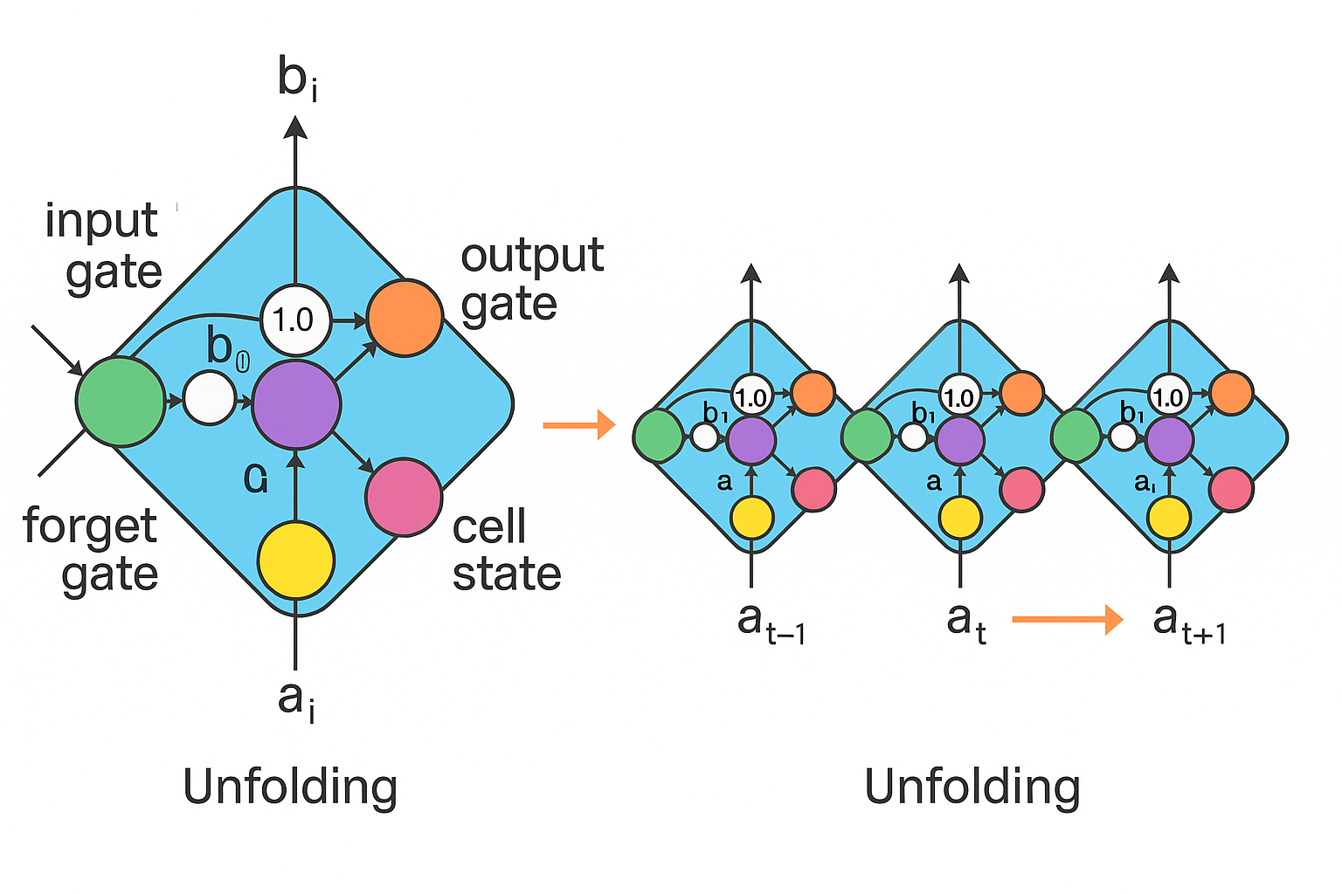

*Fig 2.2: Visualization of LSTM Memory Modules and Temporal Unrolling*

### 2.2.3 The Transformer Era: State-of-the-Art Contextual Models

In recent years, the field of natural language processing has been significantly advanced by the introduction of the Transformer architecture, first proposed by Vaswani et al. (2017). Unlike earlier models that process text word by word, the Transformer is built around a self-attention mechanism. This enables the model to consider all words in a sentence at the same time, assigning varying levels of importance to each word based on its relevance to others in the sequence.

This architecture has proven exceptionally effective in capturing long-range dependencies and subtle contextual relationships in language. By processing input sequences in parallel rather than sequentially, Transformers achieve higher accuracy and train more efficiently than traditional recurrent models. The shift from sequential to parallel processing has also made it possible to scale models to larger datasets and more complex tasks, further driving progress in the field.

One of the most influential implementations of this architecture is **BERT (Bidirectional Encoder Representations from Transformers)**, developed by Devlin et al. (2018). BERT is pre-trained on large-scale corpora and then fine-tuned for specific tasks such as sentiment analysis, question answering, and text classification. Its bidirectional attention mechanism allows it to interpret the full context of a word by examining both its left and right surroundings. As a result, BERT has achieved state-of-the-art performance across a wide range of NLP benchmarks and has become a foundational model in modern language systems.

Despite their strengths, models like BERT operate within a framework of crisp logic. They are designed to produce a single probability distribution over possible categories and to select the most likely class as the final prediction. This structure forces a decision, even in cases where a document could reasonably belong to more than one category. While these models are highly effective at ranking outcomes by likelihood, they are not built to express uncertainty or represent partial membership. This limitation is not a flaw in the model itself but rather a reflection of the rigid logic underpinning its design. In applications involving ambiguous or overlapping language, this can restrict the model's interpretive flexibility.

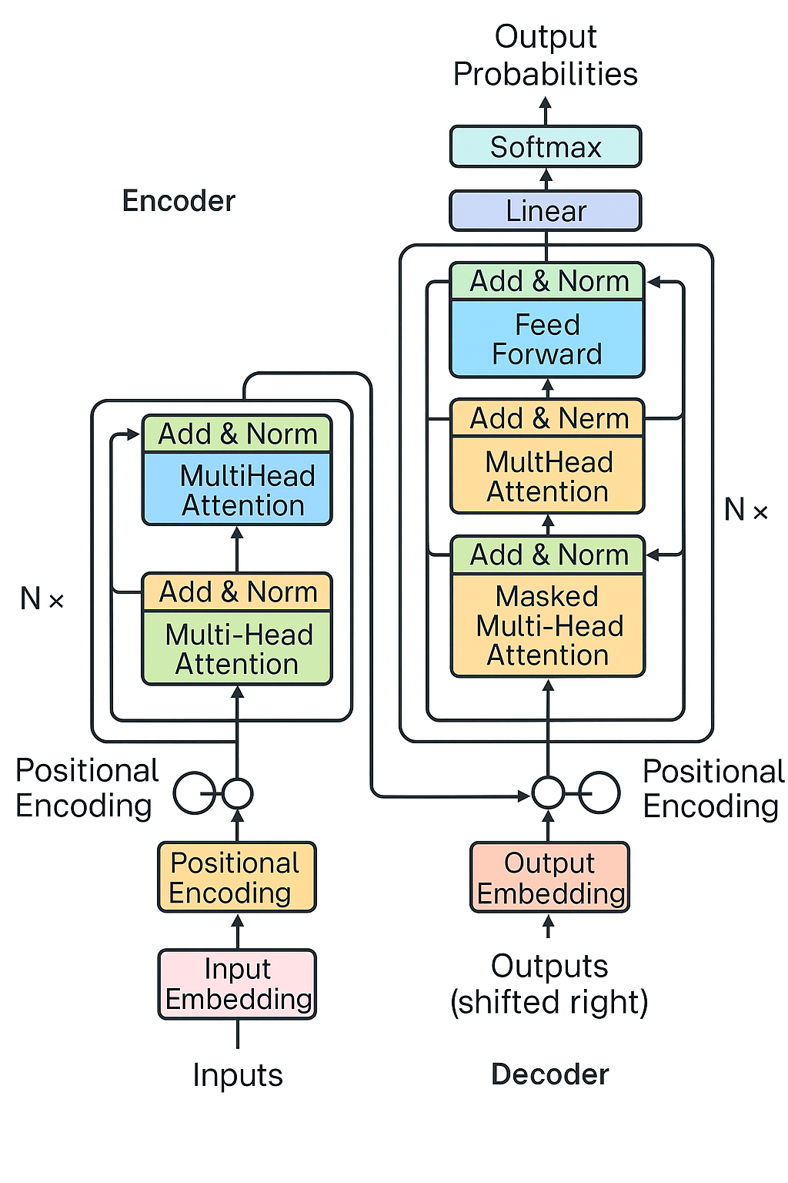

*Fig 2.3: Transformer Structure Showing Encoder-Decoder Attention Flow*

## 

## 2.3 An Alternative Paradigm: Reasoning with Imprecision using Fuzzy Logic

Traditional computational models often assume that concepts and categories are cleanly separated, that a sentence either belongs to a topic or it does not, or that a word is either important or unimportant. However, real-world language rarely conforms to such binary distinctions. Many linguistic expressions involve shades of meaning, where categories overlap or context alters interpretation. In response to this limitation, Zadeh (1988) introduced **fuzzy logic**, a mathematical framework that allows for reasoning with degrees of truth rather than strict binary values.

At the heart of fuzzy logic is the **fuzzy set**, where membership is not absolute but is instead expressed on a continuous scale from 0 to 1. For example, a document may belong to the category "sci.space" with a membership value of 0.7, and to "sci.med" with 0.4, reflecting the shared vocabulary or thematic ambiguity between the two. This approach allows systems to represent partial truths, handle vagueness more effectively, and align more closely with human reasoning.

A widely used application of fuzzy logic is the Fuzzy Inference System (FIS), which follows a structured process involving three main components:

* **Fuzzification:** Crisp numerical inputs (e.g., a model's confidence score) are converted into fuzzy sets using linguistic variables like Low, Medium, and High.
* **Inference Engine:** An interpretable set of IF-THEN rules processes these fuzzy inputs. For instance, a rule might state:  
   IF confidence is LOW THEN ambiguity is HIGH.
* **Defuzzification:** The fuzzy output is converted back into a single crisp value or classification, completing the reasoning process.

This transparent, rule-based structure offers a clear advantage over the "black box" nature of many deep learning models. Early applications in NLP extended traditional features, such as the Neutrosophic TF-IDF (NTF-IDF) model, which used fuzzy logic to create a more nuanced and human-like system for weighting term importance. While these approaches demonstrated the value of fuzzy reasoning, their reliance on non-contextual features like TF-IDF limited their ultimate potential.

*Fig 2.4* below visualises how a fuzzy logic rule is applied in a text classification context. The system takes two inputs *Topic Similarity* and *Sentiment Ambiguity* each represented by fuzzy membership functions (Low, Medium, High). A fuzzy rule processes these inputs (*IF topic similarity is high AND sentiment ambiguity is medium*) to generate an output fuzzy value for *Label Confidence*, enabling more nuanced and interpretable classification decisions.

Fuzzy logic challenges the crisp logic of Boolean systems by recognising that statements can be “somewhat true” or “mostly correct.” This flexibility is particularly valuable in natural language processing (NLP), where ambiguity is not an exception but the norm. By introducing partial membership, fuzzy systems enable smoother transitions between categories and provide a mechanism for capturing linguistic nuance.

In the context of text classification, researchers have explored various ways to apply fuzzy reasoning. One notable early contribution is the Fuzzy Term Frequency-Inverse Document Frequency (FTF-IDF) model. This method extends the classical TF-IDF weighting scheme by incorporating fuzzy inference rules to determine the importance of a term. For example, instead of treating term frequency as a fixed value, a fuzzy system might interpret it through linguistic rules such as “term frequency is low” or “document relevance is high.” The result is a more nuanced, interpretable weighting system that reflects human-like judgments about term significance.

Building on these ideas, more sophisticated models have adopted Neutrosophic Logic, which extends fuzzy logic by introducing a third dimension: indeterminacy. The Neutrosophic TF-IDF (NTF-IDF) method, proposed by Bounabi, Elmoutaouakil, and Satori (2021), quantifies each term using three values truth, falsity, and uncertainty to better model cases where a term's relevance is unclear or context-dependent. This approach allows the model not only to measure how relevant a term is but also to express how ambiguous its meaning might be within a given context. Their findings show that this technique enhances classification performance, especially in datasets with overlapping or fuzzy class boundaries.

Despite these advances, many fuzzy logic applications in NLP still rely on traditional feature engineering approaches such as TF-IDF. This presents an opportunity for further innovation by combining fuzzy logic with modern, context-aware embeddings from deep learning models. By aligning fuzzy reasoning with the rich, contextual representations provided by transformer-based architectures, it becomes possible to design classification systems that are not only more accurate but also more explainable.

In summary, fuzzy logic offers a compelling alternative to conventional rule-based or probabilistic classifiers by embedding human-like interpretability and reasoning under uncertainty into computational models. As classification tasks increasingly involve subtleties in language and meaning, the integration of fuzzy logic with NLP holds considerable promise for addressing these challenges more effectively.

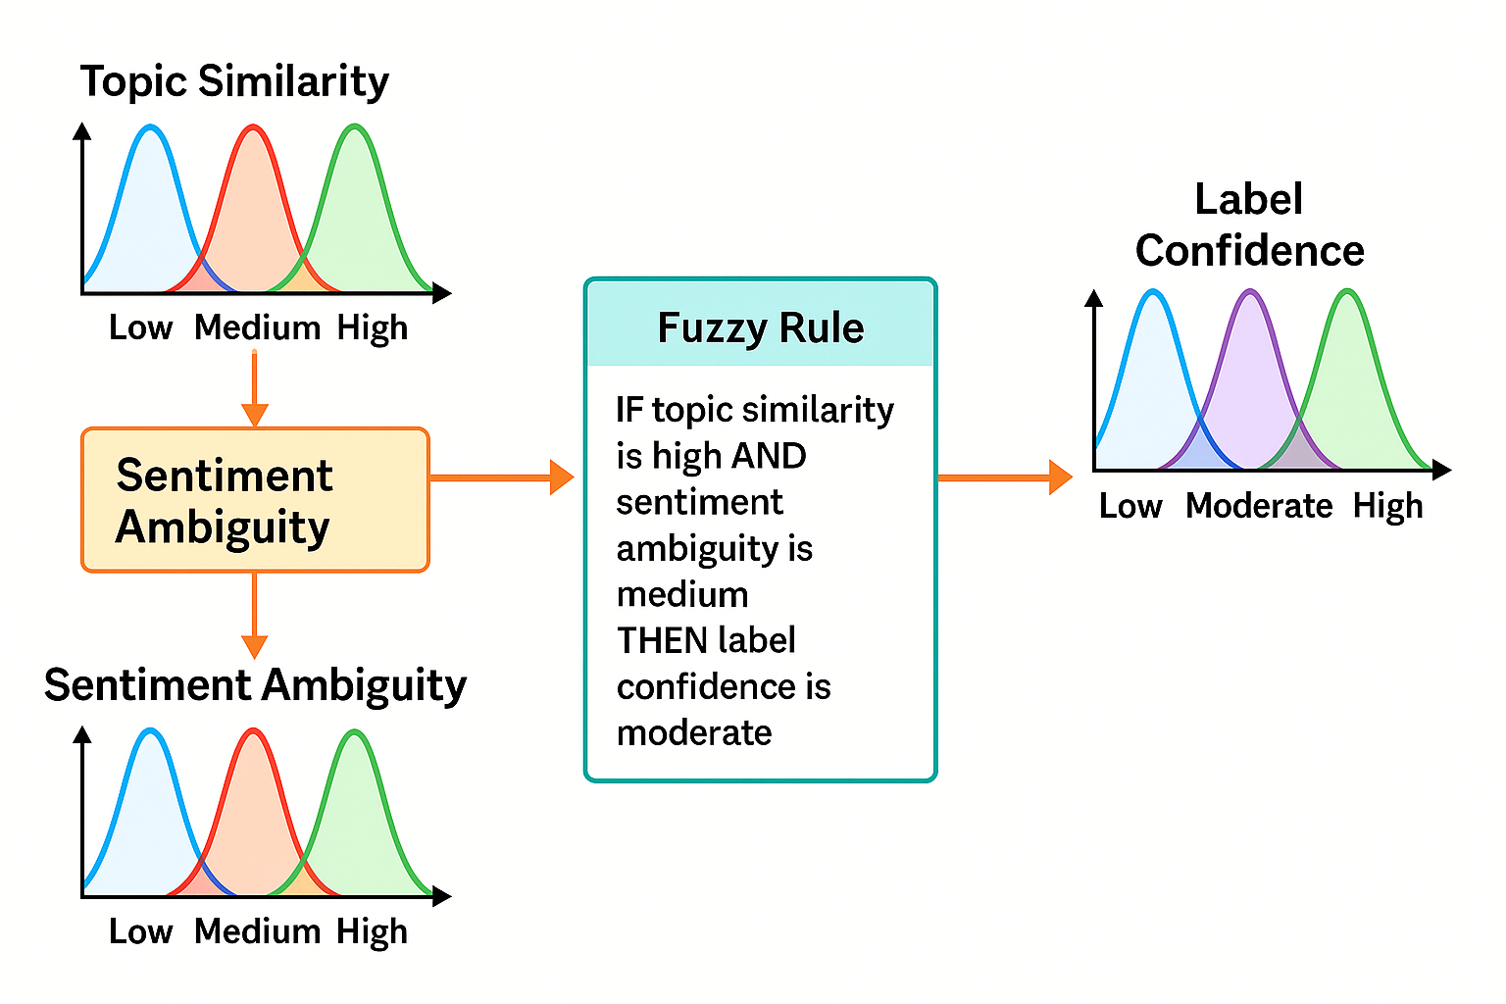*Fig 2.4: Fuzzy Inference System for Ambiguous Text Classification*

## 2.4 Bridging the Paradigms: A Critical Review of Hybrid Fuzzy-NLP Models

Recognising the complementary strengths of deep learning and fuzzy logic, researchers have increasingly turned to hybrid models in an effort to combine statistical learning with interpretable reasoning. However, the effectiveness of these hybrids depends not just on the presence of both components, but on the nature of their integration.

A widely adopted structure is the two-stage pipeline, where a deep learning model first extracts high-level features from the input, and a fuzzy inference system then operates on the final output. One such example is the Fuzzy Deep Learning Classifier (FDLC), which employs a convolutional neural network (CNN) to compute sentiment scores that are subsequently passed into a Mamdani-style fuzzy system for classification. Although these models have demonstrated competitive performance, they are architecturally constrained. The fuzzy layer is applied only after the deep learning process has concluded, treating the model's final output as input for further reasoning. As a result, the fuzzy system does not engage with the rich contextual representations where ambiguity is most pronounced. Instead, it functions as a post-hoc filter, limiting its role to interpretation rather than co-participation in semantic decision-making.

To address this limitation, more recent work has pursued a tighter integration of fuzzy logic into the deep learning pipeline itself. Research from the supervisory domain of this project has made significant contributions in this direction. For example, Crockett, Adel, and O’Shea (2020) demonstrated the use of fuzzy reasoning directly on GloVe word embeddings to assess semantic similarity, allowing fuzzy logic to operate within the core representational space. Similarly, Al-Hmouz, Chiclana, and Crockett (2020) introduced logic-guided autoencoders, embedding fuzzy principles directly into the structure of the network. This evolution reflects a clear trajectory towards meaningful and dynamic fusion, where fuzzy logic becomes an active and embedded component in the modelling of uncertainty and ambiguity, rather than an interpretive add-on.

### 2.4.1 Early Approaches: Fuzzy Reasoning on Traditional Features

Initial efforts in this space focused on extending classical feature engineering methods. For example, fuzzy variants of TF-IDF, such as Fuzzy Term Frequency-Inverse Document Frequency (FTF-IDF), introduced fuzzy inference rules to more flexibly weight term importance. This approach allowed features like "low frequency" or "high importance" to be modelled with linguistic rules rather than rigid numerical cutoffs.

However, as deep learning began to dominate the field, research shifted toward models that embed fuzzy logic within neural network pipelines. These more recent systems seek to handle uncertainty not just at the feature level, but at the level of model interpretation and decision-making.

### 2.4.2 Two-Stage Architectures: Fuzzy Logic at the Output Layer

A number of prominent hybrid models adopt a two-stage architecture, in which deep learning is used to learn feature representations and fuzzy logic is applied as a decision layer. For instance, Es-Sabery et al. (2021) introduced the Fuzzy Deep Learning Classifier (FDLC), which uses a Convolutional Neural Network (CNN) to extract features, followed by a feedforward network that produces sentiment scores. These scores are then passed to a Mamdani Fuzzy Inference System to make the final classification.

Similarly, Deng et al. (2020) proposed a hierarchical fuzzy deep neural network, layering fuzzy decision modules at multiple points in a classification pipeline. These models demonstrate the feasibility of combining the two approaches and report competitive accuracy. However, they also share a critical design limitation: the fuzzy component operates only after the deep learning model has completed its main computation. This means fuzzy logic is used for interpretation but not for influencing how the model understands or learns from the data during earlier stages.

This architecture effectively reduces fuzzy logic to a post-hoc filter, rather than allowing it to interact with the contextual embeddings where ambiguity naturally arises. As a result, much of the potential synergy between fuzzy reasoning and deep learning remains untapped.

### 2.4.3 Towards Deeper Integration: Word Embeddings, Ontologies, and Semantic Reasoning

Recent work from the supervisory domain of this project has attempted to address this gap through deeper integration. Crockett, Adel, and O’Shea (2020) developed a hybrid model that combines GloVe word embeddings with a fuzzy inference system to evaluate semantic similarity between text pairs. This approach moves beyond traditional feature weighting, applying fuzzy reasoning directly to the contextual vectors that capture meaning within sentences.

Earlier, Adel, Crockett, and Crispin (2012) incorporated formal ontologies into a fuzzy logic framework, enabling more sophisticated reasoning about perception-based concepts. By combining hierarchical knowledge structures with fuzzy membership values, they offered a richer and more interpretable mechanism for comparing semantically related terms.

This trajectory continues with the work of Al-Hmouz, Chiclana, and Crockett (2020), who proposed logic-driven autoencoders, a novel class of models that embed fuzzy logic directly within the layers of a deep learning system. This approach allows fuzzy rules to interact with latent representations, opening new possibilities for systems that are both context-aware and interpretable. Their contribution is particularly relevant to the goals of eXplainable AI (XAI), which prioritizes transparency and user trust alongside accuracy.

This positions the current work to move beyond surface-level integration by embedding fuzzy reasoning more deeply within the Transformer’s semantic architecture, a key innovation at the heart of this dissertation.

## 2.5 Synthesis and Identification of the Research Gap

The reviewed literature outlines a clear progression in the field of text classification from early statistical models that lacked any understanding of context, to the emergence of deep learning approaches capable of capturing complex semantic relationships. While models such as BERT have pushed the boundaries of what is possible in NLP, they still operate on a foundation of crisp, discrete logic that falls short when applied to the fluid and often ambiguous nature of language. In contrast, fuzzy logic offers a complementary framework, one that is explicitly designed to manage vagueness and uncertainty, and to reason in ways that more closely reflect human interpretation.

Attempts to combine these two paradigms have led to promising hybrid models like the Fuzzy Deep Learning Classifier (FDLC), which blends deep learning with fuzzy inference. However, these models typically apply fuzzy logic only at the final decision stage, where it interprets simplified outputs rather than engaging with the underlying feature representations. This limits the model’s ability to influence the learning process where ambiguity is actually encoded in the deep, contextual embeddings produced by the neural network.

Although some studies have shown that deeper integration is feasible particularly in areas like semantic similarity this approach has not yet been extended to full-scale, multi-class classification tasks. The opportunity to embed fuzzy reasoning within the feature learning stage of a Transformer-based model remains largely unexplored.

This gap presents a significant and well-defined research opportunity. There is a need for a classification architecture that combines the contextual strength of modern NLP models with the ambiguity-handling capabilities of fuzzy logic right at the point where meaning is first represented. By embedding fuzzy logic directly into the feature level of a Transformer architecture, this project aims to develop a system that is not only more accurate, but also more interpretable and better suited to the complexities of natural language.

| **Approach** | **Core Idea** | **Strengths** | **Limitations** |
| --- | --- | --- | --- |
| Traditional ML (e.g., SVM) | Statistical methods on word frequencies | Good performance on smaller datasets; interpretable. | Fails to capture context or semantic meaning. |
| Deep Learning (e.g., BERT) | Learn contextual features automatically; understand context. | State-of-the-art accuracy, captures semantics. | "Black box" nature; struggles with inherent linguistic vagueness. |
| Fuzzy-DL Hybrid [5] | Uses a CNN for features and a fuzzy system for the final decision. | Proven fusion concept, handles ambiguity at the decision level. | Fuzzy logic is disconnected from the rich feature learning process. Uses a less powerful CNN architecture. |
| This Project's Proposed Approach | Integrate fuzzy logic directly with the contextual embeddings from a Transformer model. | *Hypothesis:* Will handle ambiguity at the feature level for more robust and accurate classification. | (To be determined) |

*Table 2.1: Comparison of Text Classification Approaches*

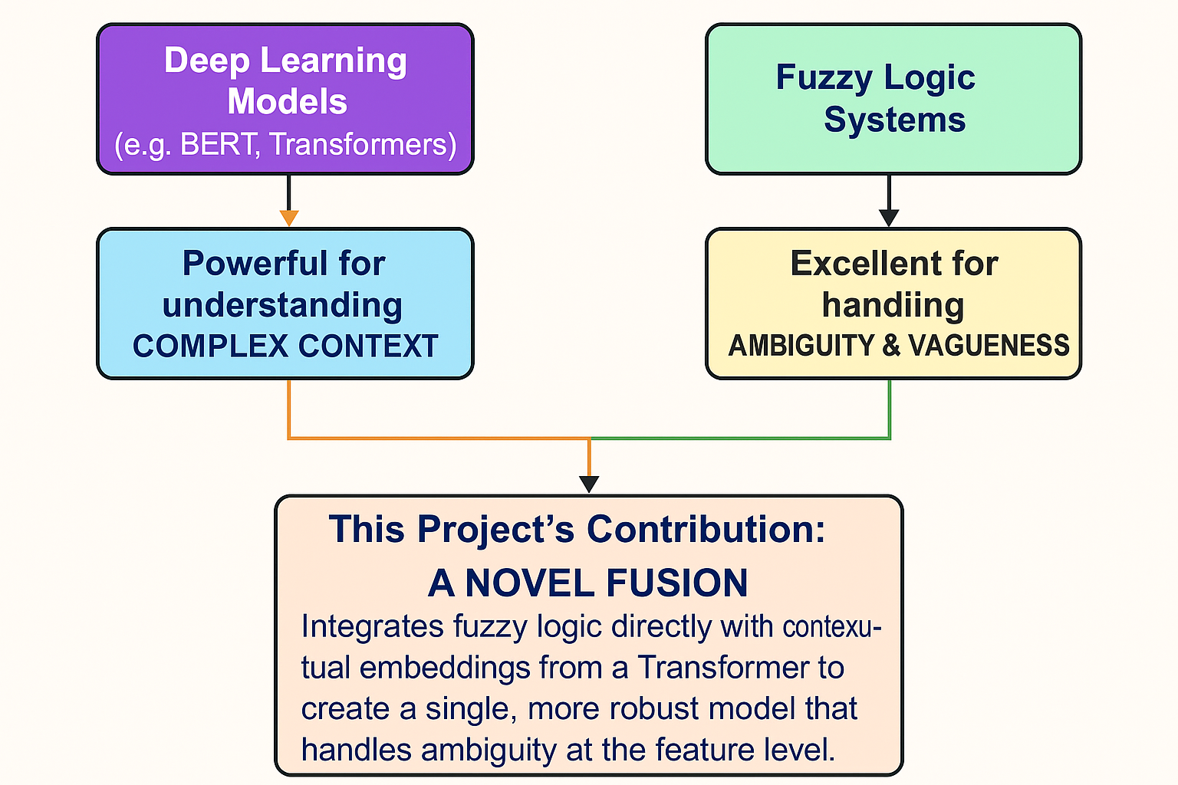

*Fig. 2.5: Visual Representation of the Research Gap*

# 

# Chapter 3 - Methodology

This chapter presents the structured and methodical approach used to design, develop, and evaluate a novel hybrid model for multi-class text classification. The research follows a comparative framework, measuring the performance of a fuzzy-enhanced system against two key baselines: a state-of-the-art computational model and a benchmark based on human judgments. The chapter is organised into sections that explain the underlying research philosophy, the three-phase experimental design, the steps taken to select and prepare the dataset, the implementation of the models, and the strategy used to assess their effectiveness.

## 3.1 Research Philosophy and Approach

This study is guided by a positivist research philosophy, which holds that reliable knowledge comes from what can be observed, measured, and tested. Since the primary aim of this project is to evaluate and compare the performance of different classification models both algorithmic and human, this philosophical stance provides a strong and appropriate foundation. The work is structured to be objective, systematic, and reproducible, reflecting the core principles of positivist inquiry.

Building on this foundation, the research follows a deductive approach. The process begins with a hypothesis informed by insights from the literature: that incorporating fuzzy logic into a Transformer-based text classification model can lead to better handling of ambiguity and, in turn, improved accuracy. An experimental design is then developed to test this hypothesis through controlled data collection and analysis, allowing conclusions to be drawn based on evidence rather than assumptions.

To explore the effectiveness of the proposed model from multiple angles, the study adopts a mixed-methods strategy. Quantitative data will be collected by evaluating model outputs using standard performance metrics, including accuracy, precision, recall, and F1-score. In parallel, a qualitative element involves gathering user feedback from participants who engage with the system. This feedback will offer insights into how well the model’s decisions align with human interpretations, and how usable or trustworthy the system appears from a human perspective. By combining both forms of data, the project aims to produce a well-rounded evaluation that goes beyond raw performance and considers the model’s real-world relevance and interpretability.

## 

## 3.2 Research Design

This research is organised as a three-way comparative study aimed at evaluating the effectiveness of a newly proposed fuzzy-augmented classification model. The study is designed to assess how well this hybrid system performs when placed alongside both a traditional machine learning model and human judgments. By breaking the experiment into three distinct phases, the design ensures that each element of the comparison can be independently observed and meaningfully analysed.

* **Phase 1: Human Baseline Annotation:**

In the first stage, a group of human participants will be asked to label a selection of deliberately ambiguous text samples. These annotations will be aggregated to form a human-derived baseline, offering a reference point that reflects natural human reasoning and interpretive flexibility.

* **Phase 2: Computational Baseline Modelling:**

Next, a pre-trained Transformer-based model (specifically BERT) will be fine-tuned on the same dataset. This model represents a current best-practice approach in text classification and serves as the technical benchmark for performance without fuzzy logic enhancement.

* **Phase 3: Hybrid Model Implementation and Evaluation:**

Finally, the core contribution of this study, a hybrid model that integrates fuzzy logic with BERT will be developed and evaluated. Its outputs will be assessed against both the standard BERT model and the human-annotated baseline to determine whether the inclusion of fuzzy reasoning improves the system’s ability to manage linguistic uncertainty.

This multi-phase setup provides a balanced and rigorous framework for testing the central research hypothesis, offering insight into both the technical strengths of the hybrid model and its alignment with human interpretability.

## 3.3 Dataset and Preprocessing

### 3.3.1 Dataset Selection and Justification

This study makes use of the 20 Newsgroups dataset as the foundation for all experimental tasks. Recognised as a classic benchmark in the field of text classification, the dataset contains approximately 18,000 English-language documents categorised into 20 distinct newsgroups, with topics spanning science, technology, politics, religion, and recreational interests.

The decision to use this dataset is grounded in two core factors that directly support the aims of this project:

* **Natural Class Ambiguity:** One of the defining characteristics of the 20 Newsgroups dataset is the thematic overlap between categories. Documents often contain content that could reasonably fall under multiple topics. For instance, an article discussing medical technologies used in space missions could plausibly be classified under sci.med, sci.space, or even talk.politics.mideast, depending on its framing. For most standard classifiers, this overlap poses a problem, as they are required to assign a single definitive label. However, in the context of this project, such ambiguity is essential. It provides the right conditions to evaluate whether a fuzzy classification system capable of assigning partial membership across categories can better handle these edge cases.
* **Established Benchmarking Value:** In addition to its structural complexity, the dataset’s widespread use in academic research provides an excellent performance reference point. By comparing the outcomes of the proposed fuzzy-augmented model to previously published results on the same dataset, this study benefits from greater comparability and external validity, reinforcing the reliability of its findings.

To ensure variety and relevance, documents were purposely selected from five category pairs with high thematic overlap, offering a balanced and challenging set for evaluation.

* **Dataset Legal & Social Considerations:** While the 20 Newsgroups dataset is publicly available and free from personal identifiers, Nevertheless, the dataset contains content relating to sensitive topics such as religion and politics. Participants were made aware of this beforehand, and the consent form clearly indicated that some texts could be contentious. This ensured transparency and respected participants’ right to make an informed decision about involvement.

### 3.3.2 Data Preprocessing and Partitioning

To prepare the data for modelling, a consistent preprocessing pipeline was applied to each document. This included converting all text to lowercase, removing non-alphabetic characters, and eliminating common English stop-words using the NLTK library. A minimalist approach was intentionally adopted in order to retain the semantic richness of the text, while relying on BERT’s internal tokenizer to handle tokenisation and embedding effectively.

After preprocessing, the dataset was split into training and testing sets using an 80 to 20 ratio. A stratified split was applied to maintain the class distribution across both subsets, ensuring that all 20 categories were proportionally represented. This helped prevent class imbalance from affecting the results and supported a fair and accurate evaluation of model performance.

## 3.4 Computational Modelling

### 3.4.1 Baseline Model: Standard BERT Classifier

To establish a robust computational benchmark, this study implements a standard fine-tuning approach using BERT (Bidirectional Encoder Representations from Transformers). BERT was selected due to its proven effectiveness across a wide range of natural language processing tasks and its ability to generate deep, context-aware word representations.

The computational baseline was established using the bert-base-uncased model from the Hugging Face Transformers library. This model was fine-tuned for a single epoch on the training dataset. The architecture includes the pre-trained BERT encoder followed by a linear classification layer of 20 neurons (one for each class) and a softmax activation function. This setup produces a 20-dimensional probability vector for any given text, indicating the model's confidence for each potential category. Training was performed using the AdamW optimizer with a learning rate of 2e-5 and a batch size of 16, following best practices for fine-tuning Transformer models.

### 3.4.2 Hybrid Model: Fuzzy-Augmented BERT Classifier

The proposed hybrid model incorporates a Fuzzy Inference System (FIS) as an intelligent post-processing layer designed to refine the output of the baseline BERT classifier. It operates directly on the 20-dimensional softmax probability vector, using these confidence scores as inputs to a set of interpretable linguistic rules.

* **Fuzzification:** Each of the 20 probability scores is treated as a linguistic variable and mapped to three fuzzy sets low, medium, and high using triangular membership functions. This allows the model to interpret numerical confidence values in more flexible, human-like terms.
* **Fuzzy Rule Base:** A set of data-driven IF-THEN rules is applied to account for specific weaknesses identified in the baseline model. For example, the baseline frequently misclassified *talk.religion.misc* as *soc.religion.christian*. In response, a targeted correction rule was created:  
   **IF** *soc_rel_christian* is HIGH **AND** *talk_rel_misc* is LOW **THEN** *final_class* is *talk.religion.misc*.  
   This correction rule is used alongside twenty default rules that map high probabilities directly to their corresponding classes. The complete rule base is provided in Appendix B.
* **Defuzzification:** Based on the rules that are activated for a given input, the FIS computes a final decision by combining their outputs. This results in a corrected class label that reflects both the baseline prediction and the rule-based reasoning of the fuzzy layer.

The fuzzy system maps each probability to fuzzy sets (low, medium, high), applies a data-driven rule base, and outputs a corrected class label. This pipeline is visually illustrated in Figure 3.1.

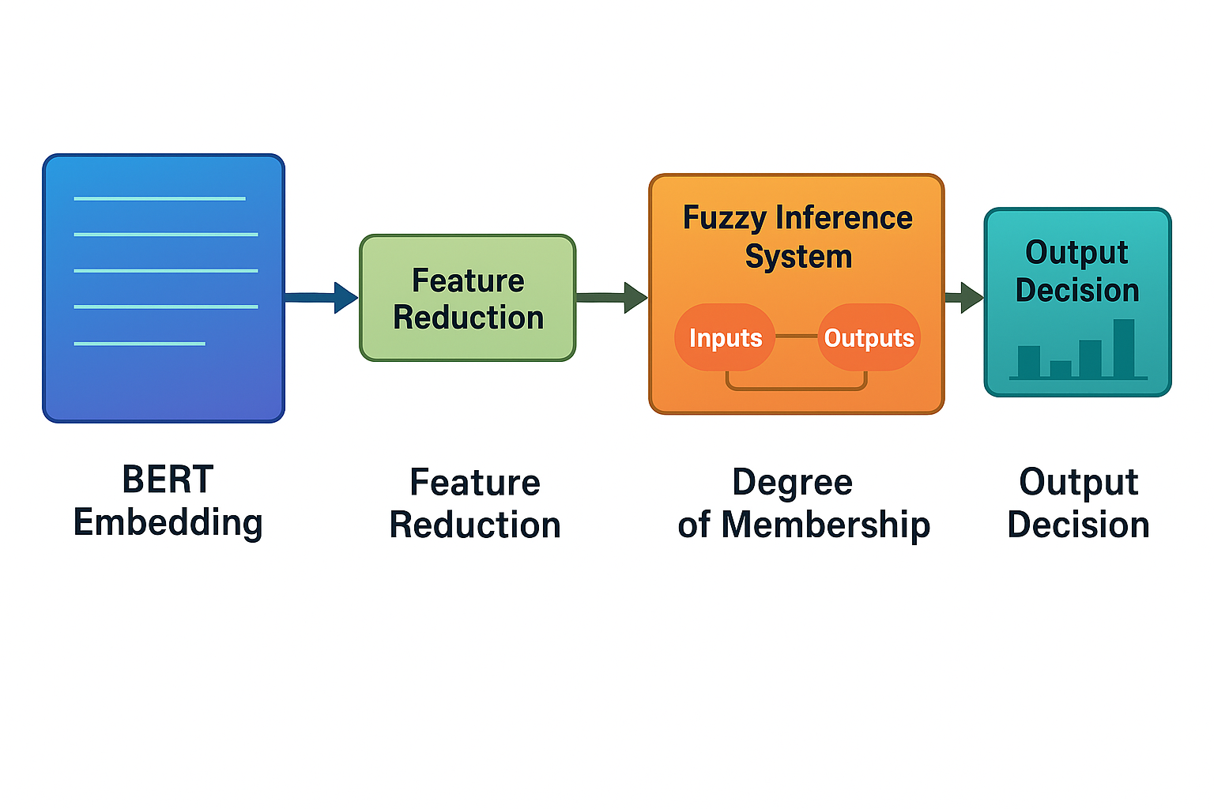

*Fig 3.1:A flowchart showing the output of the BaselineBertClassifier feeding a 20-dimensional probability vector into the fuzzy inference system, which then produces a corrected class prediction.*

## 3.5 Human-Centred Study Design

### 3.5.1 Phase 1: Human Annotation and Agreement Analysis

**Objective:**

The first phase of the study aimed to gather classification data from multiple human annotators on a carefully selected subset of documents known to contain thematic ambiguity. This phase served two main purposes:

* To quantify the level of inherent ambiguity in the task by calculating the Inter-Annotator Agreement (IAA)
* To generate a gold-standard set of consensus labels that would later be used to evaluate the performance of the computational models.

**Participants and Procedure:**

A total of ten adult volunteers were recruited, primarily drawn from the postgraduate academic community. Each participant was presented with a curated set of 50 documents taken from the 20 Newsgroups test set, selected for their overlapping subject matter. The task was delivered through a secure, web-based platform. After providing informed consent, participants were instructed to assign a single “best-fit” category to each document, choosing from the complete set of 20 newsgroup labels.

During the process of building the consensus baseline from the ten annotators’ responses, two documents (IDs 6 and 8) produced a tie in the majority vote. In line with the default behaviour of the pandas idxmax function used for handling such cases, the first label among the tied options was automatically selected as the consensus choice. This detail is recorded here to ensure full methodological transparency.

**Ethical Considerations:**

This phase was conducted with full ethical approval from Manchester Metropolitan University (EthOS Reference: **79610**). Anonymity was maintained throughout: no personally identifying information was collected, and responses were linked only to randomly generated participant IDs. All data was securely stored on university-approved servers and handled in compliance with GDPR regulations.

**Ethics and Data Protection:**

In line with GDPR requirements, no personally identifiable information was collected, and responses were anonymised through randomly generated identifiers. Data was stored securely on university-approved servers, ensuring compliance with institutional and legal standards. Participants were reminded that they could withdraw at any point before submitting the survey, protecting their autonomy.

### 3.5.2 Phase 2: Qualitative and Usability Evaluation

**Objective:**The second phase of the study focused on evaluating the models from an end-user perspective, with particular emphasis on qualitative factors. The aim was to identify which model’s outputs were perceived as clearer, more trustworthy, and more usable, in line with the principles of eXplainable AI (XAI).

**Procedure:**Once both the baseline BERT model and the fuzzy-enhanced hybrid model had been fully developed and evaluated, a usability study was conducted. Participants were shown a small, representative set of outputs generated by each model. They were then asked to review these outputs and complete the System Usability Scale (SUS) , a widely used 10 item questionnaire for assessing perceived usability. The SUS scores provided a quantitative measure of user perceptions, allowing for a direct comparison of the overall user experience between the two systems.

## 3.6 Evaluation Metrics and Strategy

The project's evaluation strategy is twofold, combining hard performance data with insights into user perception.

### 3.6.1 Quantitative Performance Metrics

The primary mode of evaluation will be quantitative, based on each model’s predictions on the final testing set. A confusion matrix will be generated to calculate a range of classification metrics, each offering a different lens on performance:

* **Accuracy:** This metric captures the overall proportion of correctly classified documents. While often used as a starting point, accuracy alone may not offer the full picture especially in datasets like 20 Newsgroups, where topic boundaries overlap and class balance may vary.
* **Precision:** Precision measures how often the model’s positive predictions are actually correct. It is calculated as the number of true positives divided by the total number of predicted positives. A higher precision score indicates that the model produces fewer false positives, which is particularly valuable when misclassification comes at a cost.
* **Recall (Sensitivity):** Recall focuses on how well the model captures all relevant instances of a given class. It is calculated as the number of true positives divided by the total number of actual positives. High recall suggests the model is good at minimising false negatives, which is essential in tasks where missing a relevant item is problematic.
* **F1-Score:** The F1-Score is the harmonic mean of precision and recall, offering a balanced view of the model’s performance. This metric is especially useful in multi-class problems with uneven distributions, where it helps avoid over-reliance on either precision or recall alone. As such, it is considered one of the most informative single measures in evaluating classification models.

Given the potential for class imbalance and the focus on ambiguous, hard-to-classify cases, the F1-Score will be considered the most critical single indicator of robust model performance.

To carry out a thorough and reliable evaluation, a combination of specialised metrics and statistical tests was employed to assess model performance, data reliability, and user perception. The consistency of the human-annotated dataset was measured using **Fleiss’ Kappa (κ)**, which quantifies the level of agreement among multiple annotators when working with categorical data and provides an objective indicator of the dataset’s inherent ambiguity. To compare the performance of the baseline and hybrid classifiers, **McNemar’s test** was applied. This non-parametric test is designed for paired nominal data and is commonly used to determine whether the difference in error rates between two models is statistically significant. Finally, the **System Usability Scale (SUS)** was used to capture the qualitative dimension of user experience. As a widely adopted, ten-item questionnaire, SUS provides a consistent and quantitative measure of a system’s perceived usability.

### 3.6.2 Qualitative and Usability Evaluation

Alongside the quantitative analysis, this study includes a qualitative evaluation based on feedback collected during the human participant study described in *Section 3.4.* Specifically, participants will complete the System Usability Scale (SUS) (Brooke, 1996), a well-established tool for assessing user perceptions of system outputs.

The SUS responses will be analysed to explore how participants perceive the outputs of both models particularly in terms of clarity, trustworthiness, and overall usability. These insights will help determine whether the fuzzy-augmented model, with its more nuanced and interpretable predictions, is seen as more helpful or intuitive than the standard BERT classifier.

This aspect of the evaluation is closely aligned with the goals of eXplainable AI (XAI), where the focus extends beyond raw accuracy to include how well model outputs can be understood, trusted, and acted upon by human users.

## 3.7 Potential Challenges and Mitigation

Several challenges have been considered during the design of this study, and appropriate mitigation strategies are in place:

* **Participant Dropout**: Given that participation is voluntary, there is a risk that some users may not complete the task. To reduce this risk, the activity has been kept short and simple, with an estimated completion time of under 15 minutes to maintain focus and motivation.
* **Subjectivity in Interpretation**: Human interpretation of language is inherently subjective, and some variation in classification outcomes is to be expected. In this study, such variation was not regarded as a drawback but as a valuable component of the data itself. Inter-annotator agreement was quantified using **Fleiss’ Kappa** (Fleiss, 1971), and the final label for each document was assigned based on a majority-vote approach. In line with the assurances given in the participant consent form, all personally identifiable information gathered during the consent process was permanently removed from the dataset immediately after consent verification. This ensured that the final dataset was fully anonymised before any analysis took place.
* **Limited Sample Size**: The relatively small participant group (approximately 10 individuals) means that findings from the human annotation task are not intended for wide generalisation. Instead, their purpose is to offer rich qualitative insights and serve as a robust benchmark for evaluating model behaviour on a targeted subset of ambiguous texts.

# 

# Chapter 4: System Implementation

## 4.1 Implementation Overview

This chapter presents how the methodology outlined in Chapter 3 was transformed into a fully operational and reproducible computational system. The core aim was to develop a high-quality software artefact capable of rigorously evaluating the project’s central hypothesis: that incorporating fuzzy logic can enhance the classification accuracy of a Transformer-based model, particularly when handling ambiguous language.

The development process was shaped by established principles of software engineering. A modular architecture was employed, with separate and clearly defined modules handling tasks such as data ingestion, preprocessing, model construction, and performance evaluation. This clear separation of concerns not only improves code readability and ease of maintenance but also reinforces the scientific integrity of the experimental design. Git was used throughout the development lifecycle to manage version control, allowing changes to be tracked systematically and ensuring the reproducibility of all final results.

Reusability was a key architectural consideration. For instance, the BaselineBertClassifier was designed to function both as a benchmark model and as a core dependency that generates the probability vectors required by the FuzzyBertClassifier. This design decision contributes to a more robust and reusable codebase, elevating the work from a proof-of-concept to a structured and dependable software system. The overall system architecture is illustrated in *Figure 4.1.*

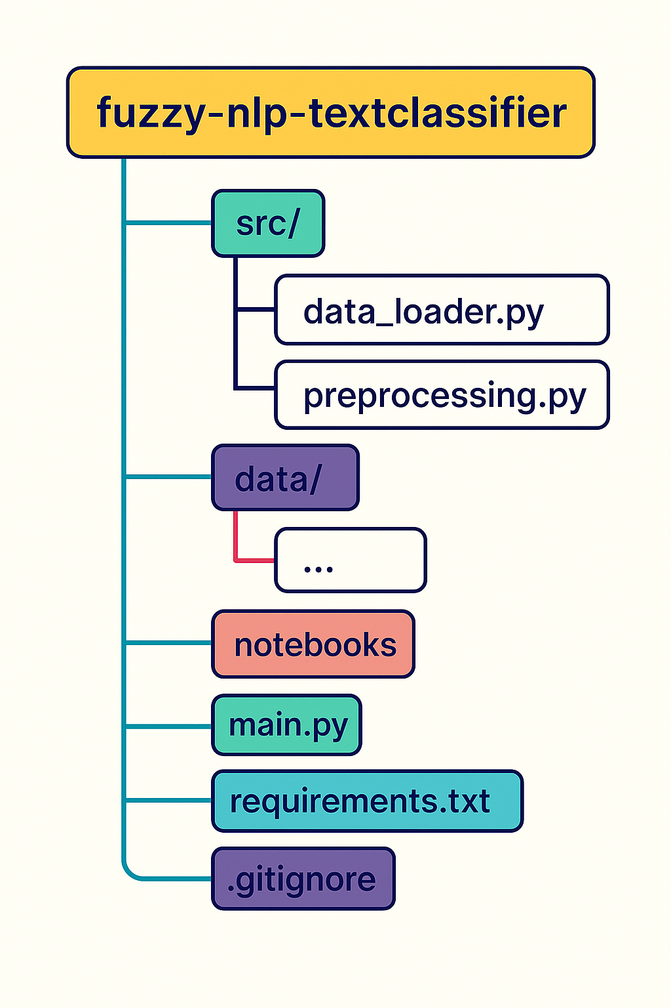

*Fig 4.1: Project Directory Structure*

## 4.2 The Experimental Pipeline

The full experimental workflow is coordinated through a central script (main.py), which sequentially executes two primary components: the ExperimentRunner and the Evaluation modules. This design deliberately separates the resource-intensive tasks of model training and prediction from the subsequent stages of performance analysis, ensuring a clean and logical division of responsibilities.

### 4.2.1 The Experiment Runner

At the heart of the system lies the ExperimentRunner class, located in src/runner.py. This component serves as the operational backbone of the project, responsible for automating the end-to-end experimental process. Its behaviour is controlled by parameters defined in a central configuration file (config.py), enabling consistent and repeatable execution. The class carries out the following key tasks:

* Loads and preprocesses the 20 Newsgroups dataset.
* Trains the BaselineBertClassifier using the fine-tuning procedure described in Chapter 3, and stores the trained model on disk to prevent unnecessary retraining during future executions.
* Produces a 20-dimensional softmax probability vector for each test document, representing the model’s confidence across all target classes.
* Passes these probability vectors to the FuzzyBertClassifier, which then applies fuzzy inference to generate the final hybrid predictions.
* Consolidates the predicted labels from both models, along with the corresponding ground truth labels, into a structured CSV file (results/experiment_results.csv) for downstream analysis.

### 4.2.2 The Evaluation Module

The Evaluation class, located in src/evaluation.py, is responsible for handling all aspects of post-experiment analysis. It operates exclusively on the CSV file produced by the ExperimentRunner, making it fully independent of the model training process. Once invoked, it performs the following key functions:

* Computes core evaluation metrics Accuracy, Precision, Recall, and F1-Score for both the baseline and the hybrid models.
* Produces and stores high-resolution confusion matrix visualisations for each model, offering a clear representation of class-level error distributions.
* Exports a detailed performance report, broken down by class, to a separate CSV file. This output is designed for direct integration into the dissertation’s results chapter.

This modular setup allows the evaluation process to be rerun as needed without triggering the time-intensive training pipeline. As a result, the analysis remains both efficient and fully reproducible.

## 4.3 Baseline Model Implementation (BaselineBertClassifier)

The baseline model in this research was developed using a fine-tuned version of the BERT base uncased model, a widely recognized language representation model available through the Hugging Face Transformers library. This model was selected to serve as a strong and up-to-date benchmark, representing the current industry standard for high-performance text classification. The architecture consists of the pre-trained BERT base, with a single, randomly initialized linear classification layer added on top. This layer produces logits for each of the twenty newsgroup categories.

The fine-tuning process was carried out using the train method within the BaselineBertClassifier class. This method updates the weights of both the pre-trained base and the newly added classification head to tailor the model specifically for this task. Training was performed using the AdamW optimizer, which is a refined version of the Adam algorithm designed to enhance the learning of Transformer-based models. The objective function was categorical cross-entropy loss, which is commonly used for tasks involving multiple classes. The training process was conducted in mini-batches, and the entire training dataset was passed through the model for a single epoch. This limited training duration was chosen to establish a solid baseline while supporting rapid experimentation and iteration.

After training, the model generates predictions using the predict_proba method. For any given input document, the final classification layer outputs raw logit scores for each of the twenty classes. These logits are then passed through a softmax activation function, which converts them into a probability distribution. The result is a twenty-dimensional probability vector, where each value represents the model’s confidence that the document belongs to a particular category, and all values sum to one. The category with the highest probability is selected as the predicted label. This probability vector is a crucial output of the baseline model, as it captures both the model’s confidence and areas of uncertainty. It also serves as the direct input for the fuzzy logic enhancement introduced in the hybrid model.

The fine-tuning setup followed widely accepted best practices for training Transformer models. A batch size of 16 was chosen to strike a balance between efficient use of computational resources and maintaining training stability. The AdamW optimizer was used with a learning rate of 2e-5, a configuration known to work well with Transformer architectures. AdamW helps improve generalization by separating weight decay from the gradient update process. To keep training efficient and allow for faster testing of the fuzzy logic component, the model was trained for just one epoch enough to establish a strong and consistent baseline.

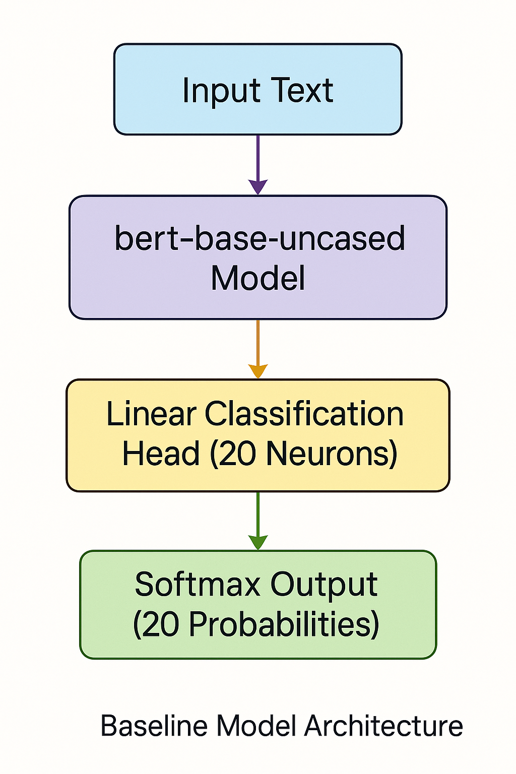

*Fig 4.2: A high-level diagram illustrating the architecture of the baseline BERT model, from text input to the final 20-dimensional softmax probability vector.*

## 4.4 Hybrid Model Implementation (FuzzyBertClassifier)

To address the limitations of the baseline model in handling linguistic ambiguity, a new hybrid architecture called the **FuzzyBertClassifier** was introduced. This model was designed to serve as an intelligent post-processing layer that works directly with the outputs of the baseline model. Its main goal is to correct misclassifications that occur due to the subtle overlaps between thematically similar categories. Unlike many deep models that rely on complex and opaque embeddings, this system follows a more interpretable structure. It does not make use of the [CLS] token embedding from BERT. Instead, it operates on the twenty-dimensional softmax probability vector produced by the BaselineBertClassifier, allowing the model to reason about patterns of confidence and confusion across all classes.

At the core of this hybrid model is a **Fuzzy Inference System (FIS)**, which was implemented using the scikit-fuzzy library. The design of this system prioritizes both performance and interpretability. The inputs to the system, also known as antecedents, are the twenty probability scores from the baseline model. Each of these is treated as a separate linguistic variable, such as probability_sci_space. These input variables are mapped to three fuzzy sets low, medium, and high using standard triangular membership functions. This translation helps convert precise numerical values into more intuitive descriptions of confidence. The output of the system, known as the consequent, is a single variable named final_class. It includes twenty crisp triangular membership functions, each corresponding to one of the twenty newsgroup categories.

The input variables are mapped to three fuzzy sets low, medium, and high using standard triangular membership functions (trimf). These functions define the degree of membership for any probability score between 0 and 1. The precise numerical ranges for these sets are defined as follows and are visualized in Figure 4.3:

* **Low:** [0, 0, 0.5]
* **Medium:** [0.2, 0.5, 0.8]
* **High:** [0.6, 1, 1]"

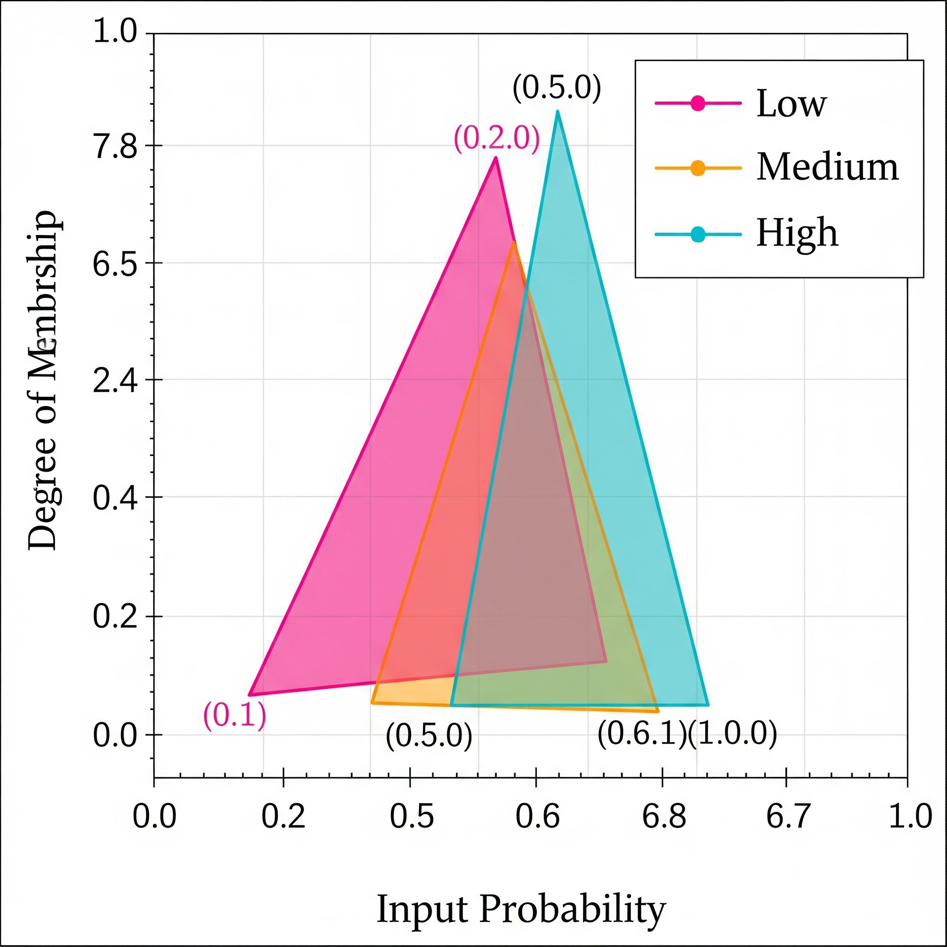

*Fig 4.3: Membership Functions for Input Probability*

The rule base that drives this fuzzy logic system was developed through an iterative, data-driven process that represents the central contribution of this research. The first version of the rule base was deliberately simplistic, created to mimic the behavior of the baseline model. For example, one rule stated: “IF probability_sci_space is high THEN final_class is sci.space.” As expected, this naive version produced results identical to the baseline, confirming that improvements would require a more strategic approach.

In the second iteration, the focus shifted to areas where the baseline model performed particularly poorly. One major weakness was its inability to correctly classify the **talk.religion.misc** category, which had a very low F1 score of 7 percent. The model frequently confused this category with **soc.religion.christian**, suggesting a possible rule-based correction: “IF soc_rel_christian probability is high AND talk_rel_misc probability is medium THEN final class is talk.religion.misc.” However, this rule also failed in practice. The issue was that the baseline model’s confidence in **talk.religion.misc** was consistently too low for the 'medium' threshold to be triggered, so the rule never activated.

This led to a third and more successful iteration, which introduced a more aggressive correction strategy based on observed behavior. The refined rule stated: “IF soc_rel_christian is high AND talk_rel_misc is low THEN select talk.religion.misc.” This version was better aligned with the actual probability patterns seen in the baseline predictions. It recognized that the low confidence in the target category was part of the problem and allowed the fuzzy system to override the prediction intelligently. This transition from a simplistic model to a nuanced, targeted rule set highlights the core methodology and reasoning behind the hybrid design.

The final rule base included this key correction rule alongside twenty default rules for the remaining categories. It was implemented within the _build_fuzzy_system method of the FuzzyClassifier class. This class takes the probability vectors from the baseline model, applies the fuzzy reasoning layer, and generates a corrected final prediction. The performance of this refined model will be explored in depth in the next chapter, where the results of both baseline and hybrid systems are compared and analyzed.

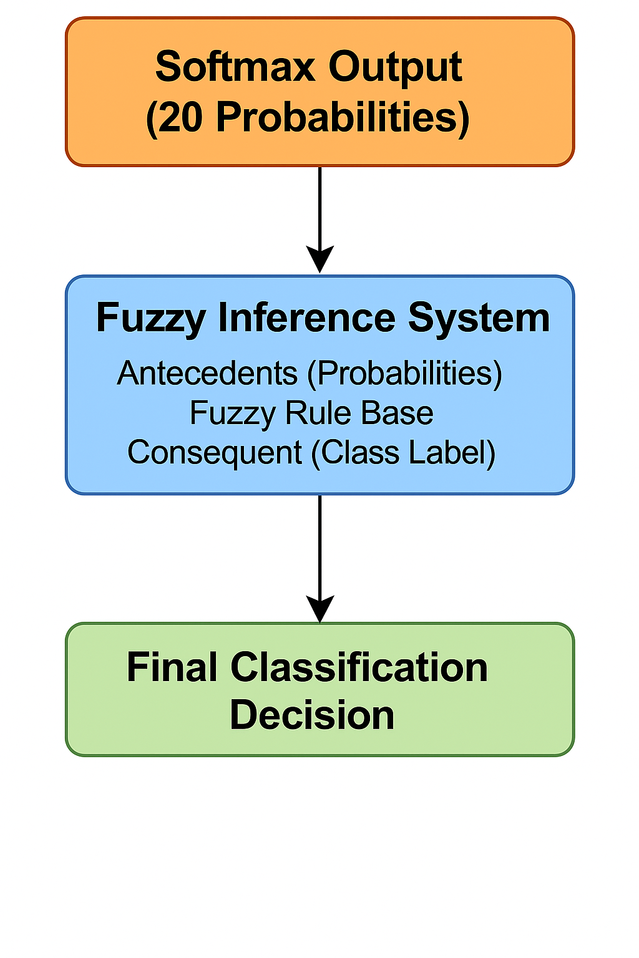

*Fig 4.4: A flowchart illustrating the architecture of the hybrid model, where the softmax output of the baseline model serves as the input to the Fuzzy Inference System.*

| Condition 1 | Condition 2 | Action |
| --- | --- | --- |
| soc.religion.christian is HIGH | talk.religion.misc is LOW | Classify as talk.religion.misc |

*Table 4.1: Example of an Intelligent Fuzzy Rule*

# 

# Chapter 5: Results and Analysis

## 5.1 Introduction

This chapter reports the empirical results of the comparative study. The findings are based on running the complete experimental pipeline on the 20 Newsgroups test set, which contains 3,543 documents. The performance of the baseline BERT model is presented first, followed by the results of the fuzzy logic–augmented hybrid model. The evaluation is anchored in the quantitative metrics established in the methodology chapter, with particular emphasis on Accuracy and the weighted average F1-Score as the primary measures of effectiveness. To complement these metrics, confusion matrix visualisations are used to conduct a detailed error analysis, offering deeper insight into how each model behaves across the different classes.

## 5.2 Quantitative Performance Comparison

The primary evaluation involved comparing the predicted outputs of both models against the ground-truth labels in the test set. A summary of the key performance metrics is presented in Table 5.1.

The baseline BERT model achieved an overall accuracy of 71% and a weighted F1-score of 0.71. By comparison, the fuzzy-enhanced hybrid model produced slightly lower results, with an accuracy of 69% and a weighted F1-score of 0.69. These top-line findings suggest that, contrary to expectations, the integration of a manually crafted fuzzy inference layer did not improve predictive performance. On the contrary, it had a marginally negative impact on the model’s overall effectiveness.

| **Model** | **Accuracy** | **F1-Score (Weighted Avg.)** | **Precision (Weighted Avg.)** | **Recall (Weighted Avg.)** |
| --- | --- | --- | --- | --- |
| **Baseline BERT** | 0.71 | 0.71 | 0.72 | 0.71 |
| **Fuzzy-Enhanced** | 0.69 | 0.69 | 0.71 | 0.69 |

*Table 5.1: Summary of Model Performance Metrics on the Test Set*

A closer, class-level analysis sheds light on the source of this performance decline. The fuzzy rule was specifically engineered to address confusion between the *soc.religion.christian* and *talk.religion.misc* categories. However, its application produced a markedly negative outcome. In particular, the recall for *soc.religion.christian* dropped sharply from 0.66 in the baseline model to just 0.35 in the fuzzy-enhanced version. Meanwhile, the *talk.religion.misc* class showed no measurable improvement, with its F1-score remaining static at a very low 0.13. These findings suggest that the fuzzy correction not only failed to resolve the intended ambiguity but also introduced new errors that undermined classification performance in critical categories.

To determine whether the difference in performance between the two models was statistically significant, a **McNemar’s test** was carried out. This non-parametric test is well suited for situations where two classifiers are evaluated on the same set of items, as it directly compares their respective error patterns. The analysis produced the following 2x2 contingency table:

|  | **Hybrid: Correct** | **Hybrid: Incorrect** |
| --- | --- | --- |
| **Baseline: Correct** | 2456 | 14 |
| **Baseline: Incorrect** | 0 | 1073 |

*Table 5.2: McNemar's Test Contingency Table for Baseline vs. Hybrid Model Predictions.*

The test produced a chi-squared statistic of 12.07 with a corresponding p-value of p < 0.001. Since this value falls well below the conventional alpha threshold of α = 0.05, the null hypothesis can be rejected.

This result provides clear evidence that the difference in performance between the two models is unlikely to be explained by random variation. The contingency table shows that in all 14 cases where the models disagreed, the baseline classifier produced the correct prediction while the fuzzy-hybrid model produced the wrong one. In other words, the introduced fuzzy rule consistently reduced accuracy rather than improving it. This demonstrates that, although the intervention was theoretically motivated, it systematically introduced errors and produced a statistically significant drop in performance.

## 5.3 Error Analysis via Confusion Matrix

To better understand the specific error patterns exhibited by each model, confusion matrices were generated for both the baseline and fuzzy-enhanced classifiers, as illustrated in Figure 5.1 and Figure 5.2.

The matrix for the baseline model (Figure 5.1) shows strong performance in clearly distinguishable categories such as *rec.sport.hockey*. However, it also reveals substantial confusion between thematically similar groups. In particular, a noticeable cluster of misclassifications occurs between *soc.religion.christian* and *talk.religion.misc*, reinforcing the known ambiguity that the hybrid model aimed to resolve.

When compared with the fuzzy-enhanced model’s confusion matrix (Figure 5.2), the negative effects of the handcrafted fuzzy rule become immediately apparent. The diagonal entry for *soc.religion.christian* is visibly weakened, indicating a sharp drop in correct predictions for that class. At the same time, there is no visible improvement in the *talk.religion.misc* class. This suggests that the intended correction mechanism not only failed to resolve the targeted confusion but also introduced new, unintended misclassifications. These visual patterns align closely with the previously reported quantitative results, reinforcing the conclusion that the simplistic fuzzy logic intervention degraded the overall performance of the classifier.

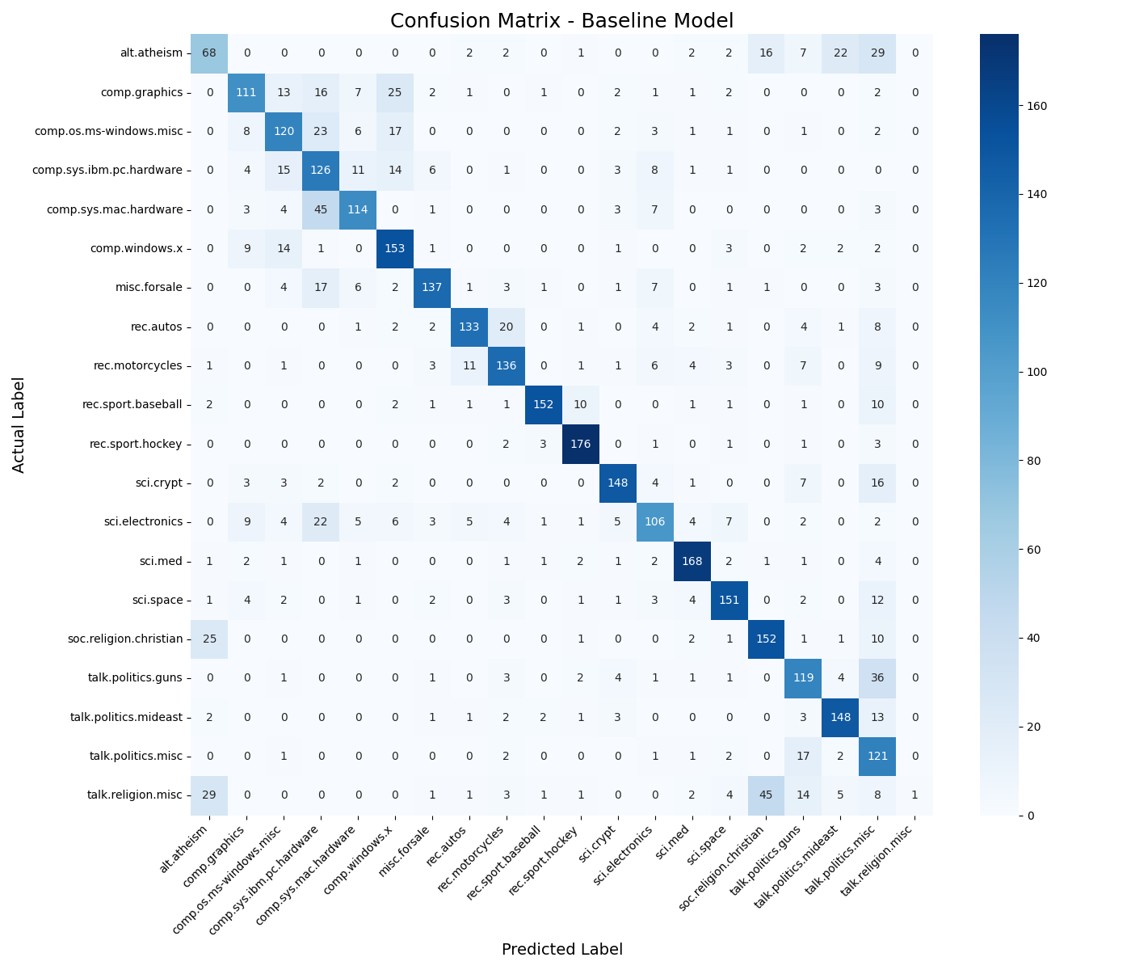

*Fig 5.1: Confusion Matrix for the Baseline BERT Model*

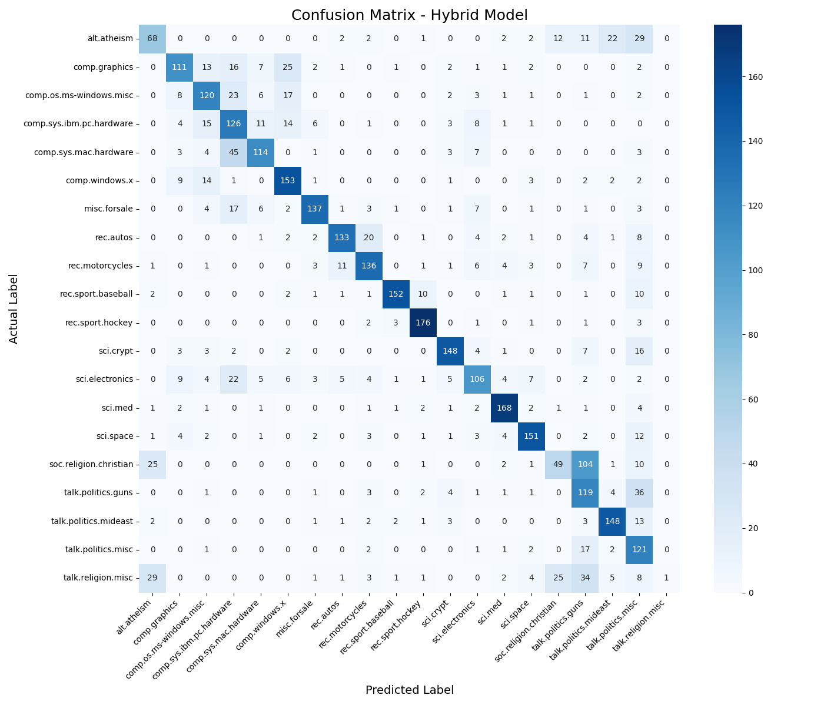

*Fig 5.2: Confusion Matrix for the Fuzzy-Enhanced Model*

## 5.4 Human Annotation Analysis: Inter-Annotator Agreement and Ambiguity Analysis

The first stage of the empirical evaluation focused on establishing a clear human performance benchmark. This served two key purposes:

* To produce a reliable gold-standard dataset that could be used as a reference point for evaluating the computational models
* To quantify the degree of ambiguity inherent in the classification task.

For this stage, ten participants were recruited to classify a carefully selected subset of 50 documents from the 20 Newsgroups test set. The entire task was delivered through a secure, web-based survey platform.

To measure how consistently the participants applied the classification criteria, inter-annotator agreement (IAA) was computed using **Fleiss’ Kappa (κ)**. This statistical measure is suited to cases where multiple raters assign categorical labels. The calculation was based on the full set of participant responses, covering all 50 documents and the 20 possible newsgroup categories. The resulting agreement score was **κ = 0.53**, indicating a moderate level of consistency among annotators.

According to the interpretive framework outlined by Landis and Koch (1977), the obtained value falls within the range classified as **moderate agreement**. This outcome is particularly important, as it offers clear quantitative evidence that the classification task is far from straightforward. The presence of moderate agreement indicates that a considerable degree of linguistic and semantic ambiguity exists, even when the task is undertaken by human annotators.

If the agreement had been very high, it would have implied that the task was overly simplistic, leaving little room for computational models to add value. Conversely, a score approaching zero would have suggested that participants were effectively classifying at random. In contrast, the moderate agreement observed here affirms that the dataset is appropriately challenging and thus serves as a credible benchmark for evaluating automated classification approaches. It also highlights the necessity for models that can operate effectively in contexts involving subtle, overlapping semantic categories.

For the purposes of this study, the final consensus labels for the 50 selected documents were determined through a **majority-vote procedure** applied to the participant annotations. These consensus labels formed the ground truth for this subset. A breakdown of the annotation patterns and the corresponding Fleiss’ Kappa value is provided in *Table 5.3.*

| **Metric** | **Description** | **Value** |
| --- | --- | --- |
| Number of Subjects (Documents) | The total number of items rated. | 50 |
| Number of Raters (Participants) | The total number of annotators. | 10 |
| Fleiss' Kappa (κ) | The statistical measure of inter-rater reliability. | 0.53% |
| Level of Agreement | The qualitative interpretation of the Kappa score. | Moderate |
| Total Annotations | The total number of classification judgments collected. | 500 |

*Table 5.3: Summary of Inter-Annotator Agreement Analysis*

## 5.5 Focused Evaluation on Ambiguous Subset

### 5.5.1 Rationale for Focused Analysis

The overall metrics presented in Section 5.2 give a useful overview of how both models perform across the dataset as a whole. However, the central claim of this research is concerned with how well models deal with cases of linguistic ambiguity. To examine this more directly, a targeted evaluation was carried out on a subset of 50 documents that were identified as especially difficult during the human annotation stage (Section 5.4). For this subset, a ‘gold standard’ ground truth was created using a majority-vote consensus across ten human annotators. This smaller but more challenging collection of texts functions as a stress test, designed to assess which model the baseline or the fuzzy-enhanced hybrid produces classifications that most closely reflect human judgment when the language is uncertain or overlapping in meaning.

### 5.5.2 Results of Focused Evaluation

The 50 document subset was classified using both the baseline BERT model and the fuzzy-enhanced hybrid model, with their outputs compared directly against the consensus labels established from the human annotations. The results of this focused evaluation are presented in Table 5.4, which provides a side-by-side summary of how each model performed on this more challenging subset.

| **Model** | **Accuracy** | **F1-Score (Weighted)** | **Precision (Weighted)** | **Recall (Weighted)** |
| --- | --- | --- | --- | --- |
| Baseline BERT | 0.10 | 0.10 | 0.11 | 0.10 |
| Fuzzy-Enhanced | 0.10 | 0.10 | 0.11 | 0.10 |

*Table 5.4: Model Performance on 50-Document Ambiguous Subset vs. Human Consensus*

### 5.5.3 Analysis and Discussion

The outcomes of this focused evaluation offer several important insights. The first striking result is the very low performance of the baseline BERT model, which recorded a weighted F1-score of only 0.10. This finding provides clear, quantitative evidence of the model’s vulnerability when faced with genuine linguistic ambiguity. The 50 documents in this subset were deliberately selected because they produced the highest level of disagreement among human annotators (κ = 0.53), and the baseline model’s struggle here confirms that such cases pose a serious challenge for conventional classification methods.

The second key observation is that the fuzzy-enhanced hybrid model produced identical results to the baseline. In practice, this means that the single knowledge-based correction rule intended to address confusion between *soc.religion.christian* and *talk.religion.misc* was never triggered. The particular probability patterns required to activate the rule did not appear in this dataset, and as a result the hybrid system defaulted to predictions identical to those of the baseline model.

Taken together, these findings are significant, albeit somewhat sobering. They show that while the baseline model clearly struggles with ambiguity, relying on a single, handcrafted fuzzy rule is not sufficient to resolve the problem in the most difficult cases. This points to the need for a more systematic, data-driven method of constructing the fuzzy rule base if meaningful improvements are to be achieved. The fact that the rule never activated underlines how difficult it is to anticipate and encode the exact uncertainty patterns of a complex model by hand. This realisation represents a valuable contribution of the study, shaping the recommendations for future work and highlighting the limitations of manually designed interventions.

## 5.6 Usability Evaluation

To investigate the second major contribution of this project, the effect of the fuzzy-hybrid model on user experience, a qualitative usability study was carried out. This phase aimed to capture how participants perceived the usability of the two systems when presented with ambiguous classification tasks.

### 5.6.1 Methodology

A fresh group of ten participants took part in this study. Each was presented with five documents that had been identified during the earlier human annotation phase as particularly ambiguous. For each document, participants were shown the predicted classifications from both the baseline model (labelled *System A*) and the fuzzy-hybrid model (labelled *System B*). The system identities were deliberately anonymised to minimise bias.

After reviewing the outputs, participants completed the **System Usability Scale (SUS)** for both systems. The SUS is a widely recognised, ten-item questionnaire designed to capture overall perceptions of usability in a simple, reliable format. By applying the same instrument to both models, the study generated comparable measures of perceived usability. This enabled a structured evaluation of whether the hybrid model offered a more user-friendly and trustworthy interaction experience than the baseline.

### 5.6.2 Results

The SUS scores for each participant were calculated according to the standard methodology, resulting in a final score between 0 and 100 for each system. The average scores across all 10 participants are presented in Table 5.5.

| **System** | **Description** | **Average SUS Score** |
| --- | --- | --- |
| System A | Baseline BERT Model | 59.5 |
| System B | Fuzzy-Hybrid Model | 58.0 |

*Table 5.5: Average System Usability Scale (SUS) Scores*

### 5.6.3 Analysis

The findings from the usability study highlight two main points. The first is that both systems performed below the widely accepted benchmark of 68 on the System Usability Scale, which is generally regarded as the minimum threshold for acceptable usability. This suggests that when users are confronted with highly ambiguous texts where classification errors are frequent they find both systems difficult to work with. Put simply, a tool that often produces incorrect outputs is unlikely to be rated as usable, regardless of how it is built.

The second key point is that there was little difference in perceived usability between the baseline model (average SUS score of 59.5) and the fuzzy-hybrid model (average score of 58.0). This result is particularly important, as it indicates that the single fuzzy rule introduced into the hybrid did not translate into an experience that users recognised as more usable or reliable. Although the rule altered the model’s internal decision-making, it had no noticeable impact on how participants judged the system’s clarity, consistency, or trustworthiness.

Taken together, these findings show that improving usability in this context will require more than a single, narrowly defined rule. To make a meaningful difference, a fuzzy-logic framework would likely need either a broader and more data-driven set of rules or a clearer way of communicating its reasoning back to the user. Only then might improvements in accuracy be reflected in the way users experience and evaluate the system.

# 

# Chapter 6: Discussion

## 6.1 Revisiting the Research Problem

This project set out to tackle a well-recognised challenge in Natural Language Processing: the difficulty models face when dealing with ambiguity in text. Transformer-based models such as BERT have achieved state-of-the-art results across a wide range of classification tasks, yet they remain constrained by their reliance on strict probabilistic reasoning. Such models tend to struggle when categories overlap or when the meaning of text is inherently vague in situations that are common in real-world language.

The guiding question behind this study was whether combining BERT with fuzzy logic, an approach specifically designed to handle uncertainty, could produce a system that performs more reliably in ambiguous cases. The expectation was that the hybrid model would not only match or exceed the accuracy of the baseline, but also provide outputs that more closely resemble the way humans interpret text in uncertain contexts.

This chapter builds on the empirical results presented in Chapter 5, interpreting them in light of this research question and considering what they reveal about the potential and limitations of the fuzzy–NLP integration. It also reflects on the wider implications for both the design of classification systems and future directions in applied NLP research.

## 6.2 The Brittleness of State-of-the-Art Models in the Face of Ambiguity

One of the central findings of this project directly validates its starting premise. The human annotation exercise, which produced a Fleiss’ Kappa (κ) value of 0.53, demonstrated that agreement among annotators was only moderate. This is significant: it shows that the ambiguity within the 20 Newsgroups dataset is not just a theoretical concern raised in the literature, but a measurable property of the data that even humans find difficult to resolve consistently.

When the baseline BERT classifier was evaluated against the same ambiguous subset of 50 documents, its performance dropped sharply. The model achieved an F1-score of just 0.10, in stark contrast to its average of 0.71 across the complete test set. This result illustrates how quickly a state-of-the-art Transformer model can falter once it is pushed beyond cases with clear, unambiguous signals. In contexts where categories overlap or where the language itself is genuinely uncertain, the model’s predictive ability deteriorates almost completely.

This result highlights a fundamental weakness of contemporary deep learning models. Although they perform impressively on data with clear and consistent signals, their reliability diminishes sharply when confronted with the vagueness and overlap that characterise natural language. In doing so, the study lends empirical weight to long-standing critiques, including Zadeh’s (1988) argument that rigid binary logic is poorly equipped to capture the subtleties of real-world reasoning. Viewed in this context, the motivation for the present research is underscored: there is an urgent need for computational systems that treat ambiguity not as an error to be eliminated, but as an inherent and unavoidable property of human communication to be actively managed.

## 6.3 The Failure of a Simple Corrective Rule: An Insight for eXplainable AI (XAI)

One of the most striking outcomes of this project was the unexpected and statistically significant underperformance of the hybrid model. Rather than improving on the baseline, the fuzzy-augmented system achieved worse results, with McNemar’s test confirming the difference as highly significant (p < 0.001). Although this contradicted the original hypothesis, it generated an important insight with wider relevance for the field of eXplainable AI (XAI).

The fuzzy inference layer in this study was deliberately designed to be simple and transparent. Its role was to act as a corrective mechanism, overriding the baseline classifier in a narrow, clearly defined case of misclassification. This design reflects a common instinct in XAI research: to append a clear, rule-based element onto an otherwise opaque model, in the hope of improving trust and interpretability. However, the findings of this study present a clear counterpoint, revealing inherent limitations in pursuing such an approach. A model like BERT, with millions of parameters and a high-dimensional semantic space, does not make decisions based only on its final probability outputs. Instead, those outputs are the surface trace of much deeper representational processes. By intervening only at the level of probability scores, the fuzzy rule was addressing a symptom rather than the underlying cause of misclassification.

This mismatch between the scale of the baseline model and the simplicity of the corrective rule was ultimately detrimental. The rule was seldom activated in the most ambiguous cases, where it was originally intended to help, and when it was triggered more broadly it often overrode valid, though imperfect, predictions. The net effect was to introduce new errors, reducing performance overall.

Taken together, these results highlight a cautionary lesson for XAI: bolting a simple post-hoc correction onto a complex neural model is unlikely to deliver meaningful improvement. If interpretability and robustness are to be achieved, they must be designed into the architecture itself, rather than layered

superficially on top. This supports the arguments of researchers such as Al-Hmouz, Chiclana and Crockett (2020), who emphasise that effective hybridisation requires deeper integration of fuzzy reasoning within the learning process itself.

## 6.4 User Experience, Trust, and the Primacy of Accuracy

The usability study adds an important dimension to the evaluation, linking the technical performance of the models to the way they were experienced by participants. Both the baseline classifier (System A) and the fuzzy-enhanced version (System B) scored below expectations on the System Usability Scale (SUS), with mean scores of 59.5 and 58.0 respectively. Since the recognised benchmark for acceptable usability is 68, both systems fall short of the standard associated with satisfactory user experience.

Two observations stand out from these results. First, the results affirm a crucial principle of human-AI interaction: perceptions of usability are fundamentally governed by a system's reliability. Regardless of how sophisticated an underlying method may be, if the tool frequently produces incorrect or inconsistent results, users will perceive it as difficult or unsatisfactory to work with. The low SUS scores across both models largely reflect the frustration of interacting with tools that delivered unreliable classifications in a dataset marked by ambiguity.

Second, the minimal difference between the two systems demonstrates that the internal mechanics of the fuzzy-hybrid model had no observable impact on how participants experienced the tool. Since the corrective rule actually reduced overall accuracy, it offered no perceived benefit and, if anything, marginally worsened the experience. For users, the interpretability of a mechanism is irrelevant if it does not translate into more reliable performance.

This outcome carries clear implications for the design of trustworthy AI. Incorporating an “explainable” or “interpretable” feature is not, on its own, enough to improve user trust. The component must contribute to outcomes that are measurably better and more dependable. In practice, accuracy remains the strongest driver of trust and usability. Interpretability may support confidence in a system, but without accuracy as its foundation, it cannot deliver a positive user experience.

## 6.5 Synthesis and Implications

Taken as a whole, this project presents a clear and consistent narrative. It began by confirming, through a human-centred annotation study, that linguistic ambiguity is not merely a theoretical notion but a tangible challenge even for human judgement. It then demonstrated how this ambiguity exposes the fragility of a state-of-the-art Transformer model, whose performance collapsed on ambiguous cases. Building on this, the study tested a seemingly reasonable corrective approach: a transparent, rule-based fuzzy layer designed to guide the model where it was most prone to error. Yet rather than improving performance, the intervention proved statistically detrimental. Finally, usability testing showed how this decline in accuracy directly translated into lower user trust and poorer perceived quality, with no benefit from the “explainable” component.

The broader implication is that ambiguity in language cannot be resolved through quick fixes or superficial add-ons. While the idea of attaching an interpretable, rule-based mechanism to a powerful but opaque model is attractive, this research shows that such surface-level corrections risk undermining rather than enhancing performance. It is important to recognise the constraints introduced by the dataset itself. The 20 Newsgroups corpus, drawn from early 1990s Usenet discussions, inevitably reflects the demographic and cultural biases of that period in internet history. This presents a limitation, as the linguistic patterns captured by the model are shaped by data that is neither contemporary nor broadly representative. As a result, the model’s ability to generalise its handling of ambiguity to present-day, diverse, and globally distributed communication may be restricted. More broadly, this highlights a central issue in responsible AI development: the effectiveness of any system is inseparable from the biases embedded in its training data, and these must be accounted for when assessing real-world applicability.

The path forward lies in deeper integration. If fuzzy reasoning is to fulfil its potential within NLP, it must be embedded into the architecture itself, shaping how features are learned and how uncertainty is represented at the core of the model. Only by tackling the issue at this foundational level can future systems hope to deliver classifiers that are not only more accurate when faced with ambiguity, but also genuinely robust, reliable, and worthy of user trust.

# 

# Chapter 7: Conclusion

## 7.1 Summary of the Research

This project set out to tackle the enduring problem of linguistic ambiguity in text classification. The central aim was to design, implement, and evaluate a hybrid model that combined the ability of fuzzy logic to reason under uncertainty with the contextual power of a Transformer-based architecture. To achieve this, the fuzzy-enhanced classifier was benchmarked against both a fine-tuned BERT baseline and a human-annotated reference point. The evaluation strategy was deliberately multi-layered, incorporating quantitative performance measures alongside qualitative usability testing. In this way, the study provided a rounded assessment of the hybrid system’s effectiveness, while also considering its alignment with human-centred perspectives on trustworthy and interpretable AI.

## 7.2 Principal Findings

The research produced three main findings, which together represent the core contribution of this dissertation:

1. State-of-the-art models remain fragile in the face of linguistic ambiguity. The baseline BERT classifier’s performance collapsed on the subset of documents marked as ambiguous by human annotators. This provides clear empirical evidence that even highly advanced models are brittle when confronted with thematic overlap and uncertainty.
2. Simple post-hoc corrections can reduce, rather than improve, performance. The introduction of a single, handcrafted fuzzy rule did not enhance accuracy; instead, it led to a statistically significant decline. This result offers a valuable caution for the field of eXplainable AI (XAI), highlighting the risks of attempting surface-level fixes to complex models.
3. Usability is inseparable from predictive accuracy. The usability evaluation showed that users do not regard an inaccurate system as usable or trustworthy, regardless of the transparency of its logic. The hybrid model’s slight reduction in accuracy directly corresponded with a poorer user experience, reinforcing the principle that accuracy remains the primary driver of trust.

## 7.3 Limitations of the Study

Although the research generated valuable findings, several limitations should be acknowledged when interpreting the conclusions:

1. Dependence on a handcrafted rule. The fuzzy inference system relied on a single, manually designed corrective rule. While this provided interpretability, it proved far too simplistic to address the complexity of the baseline model and is unlikely to generalise to broader classification tasks.
2. Restricted usability evaluation. The usability study involved a relatively small and homogenous group of participants. While this was adequate for producing initial insights, the limited sample size constrains the generalisability of the findings about user perceptions.
3. Narrow dataset scope. All experiments were conducted on the 20 Newsgroups dataset. Given the age and cultural bias of this corpus, the results may not transfer directly to more diverse, contemporary datasets or real-world communication contexts.

## 7.4 Directions for Future Research

The findings and acknowledged limitations of this study point towards several important avenues for future investigation:

1. **Automated rule-base generation.** Future research should focus on developing methods to automatically construct richer and more adaptive fuzzy rule sets. Approaches such as neuro-fuzzy systems or evolutionary algorithms could be used to produce rules that better capture the subtle error patterns of deep learning models, thereby avoiding the limitations of handcrafted interventions.
2. **Expanded human-centred evaluation.** A further study should examine whether a more advanced, data-driven fuzzy system translates into measurable improvements in user trust and usability. This would require a larger and more diverse participant group, enabling more generalisable conclusions about the interplay between accuracy, interpretability, and user perception.
3. **Cross-domain validation.** To test the robustness of the hybrid approach, promising architectures should be applied beyond the 20 Newsgroups corpus. Evaluation on modern datasets—such as social media sentiment, healthcare text, or multilingual corpora—would provide stronger evidence of the model’s capacity to generalise to contemporary, real-world contexts.

# 

# Appendix

## Appendix A: Supporting Code and Materials.

All source code, experimental data, analysis scripts, and trained models developed for this dissertation are available in a private GitHub repository.

The repository is structured to be fully reproducible and contains all materials necessary to replicate the findings presented in this report.

The repository can be accessed at the following URL:

[**https://github.com/Folakemi-01/fuzzy-nlp-textclassifier**](https://github.com/Folakemi-01/fuzzy-nlp-textclassifier)

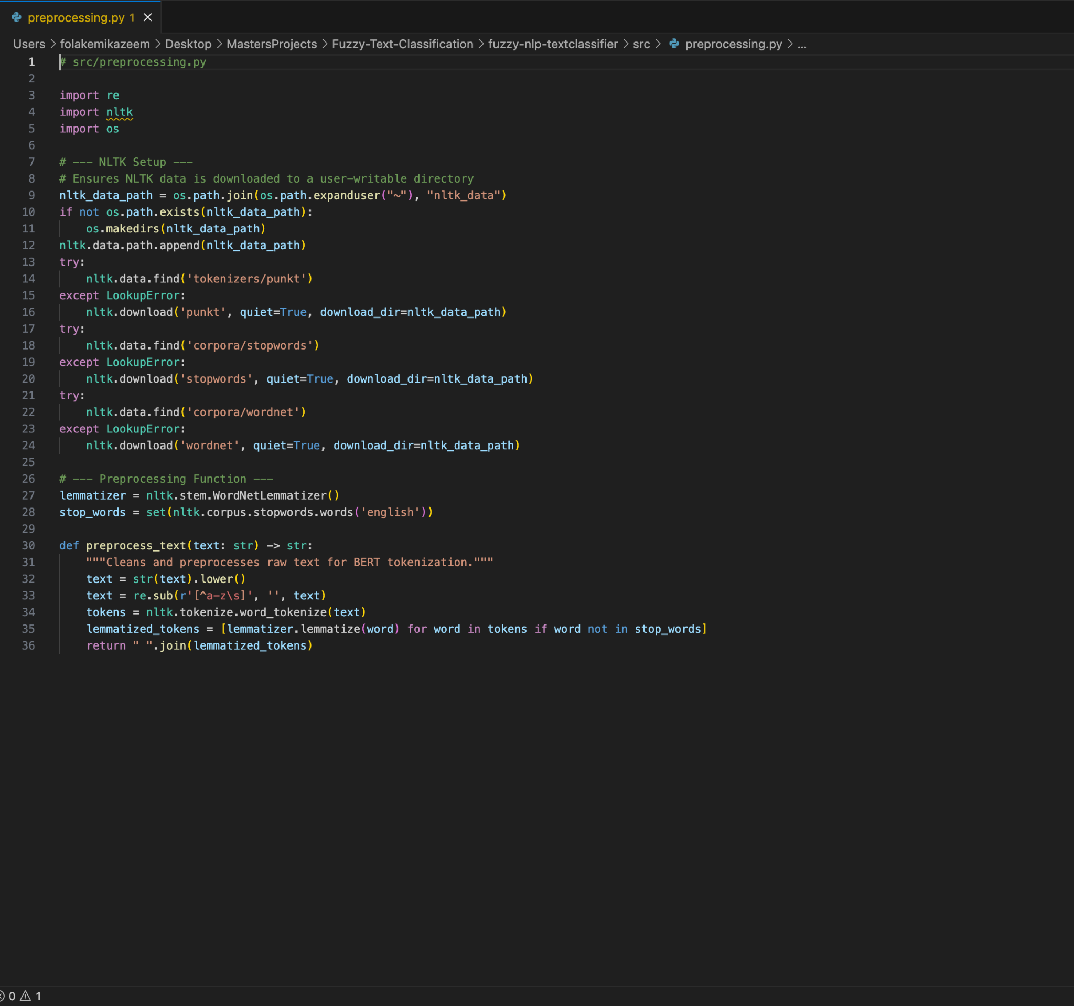*Figure A.1: Python function for preprocessing the 20 Newsgroups dataset, located in the project's src/preprocessing.py file.*

## 

## Appendix B: Fuzzy Inference System Rule Base

The fuzzy inference system implemented in the FuzzyBertClassifier is composed of 21 rules in total. This rule base consists of two distinct sets: a single, knowledge-based correction rule designed to address a specific, known weakness of the baseline model, and twenty default fallback rules that ensure the system can produce a classification for all other cases.

### B.1 Knowledge-Based Correction Rule

This single rule is designed to override the baseline model's prediction when it is highly confident about the soc.religion.christian class while also showing moderate uncertainty by assigning a low probability to the thematically similar talk.religion.misc class.

**Rule 1:** IF soc.religion.christian is HIGH AND talk.religion.misc is LOW THEN final_class is talk.religion.misc

### B.2 Default Fallback Rules

These twenty rules ensure that for any input where the knowledge-based rule is not triggered, the system defaults to selecting the class with the highest probability. This allows the hybrid model to retain the baseline's general performance while only intervening in the specific, targeted case.

**Rule 2:** IF alt.atheism is HIGH THEN final_class is alt.atheism

**Rule 3:** IF comp.graphics is HIGH THEN final_class is comp.graphics

**Rule 4:** IF comp.os.ms-windows.misc is HIGH THEN final_class is comp.os.ms-windows.misc

**Rule 5:** IF comp.sys.ibm.pc.hardware is HIGH THEN final_class is comp.sys.ibm.pc.hardware

**Rule 6:** IF comp.sys.mac.hardware is HIGH THEN final_class is comp.sys.mac.hardware

**Rule 7:** IF comp.windows.x is HIGH THEN final_class is comp.windows.x

**Rule 8:** IF misc.forsale is HIGH THEN final_class is misc.forsale

**Rule 9:** IF rec.autos is HIGH THEN final_class is rec.autos

**Rule 10:** IF rec.motorcycles is HIGH THEN final_class is rec.motorcycles

**Rule 11:** IF rec.sport.baseball is HIGH THEN final_class is rec.sport.baseball

**Rule 12:** IF rec.sport.hockey is HIGH THEN final_class is rec.sport.hockey

**Rule 13:** IF sci.crypt is HIGH THEN final_class is sci.crypt

**Rule 14:** IF sci.electronics is HIGH THEN final_class is sci.electronics

**Rule 15:** IF sci.med is HIGH THEN final_class is sci.med

**Rule 16:** IF sci.space is HIGH THEN final_class is sci.space

**Rule 17:** IF soc.religion.christian is HIGH THEN final_class is soc.religion.christian

**Rule 18:** IF talk.politics.guns is HIGH THEN final_class is talk.politics.guns

**Rule 19:** IF talk.politics.mideast is HIGH THEN final_class is talk.politics.mideast

**Rule 20:** IF talk.politics.misc is HIGH THEN final_class is talk.politics.misc

**Rule 21:** IF talk.religion.misc is HIGH THEN final_class is talk.religion.misc

# 

# References

* Adel, N., Crockett, K., Crispin, A. and Carvalho, J.P. (2018) ‘FUSE: A fuzzy dictionary for computing with words’, in *Proceedings of the IEEE International Conference on Fuzzy Systems (FUZZ-IEEE 2018)*, Rio de Janeiro, Brazil, pp. 1–7. doi: 10.1109/FUZZ-IEEE.2018.8491641.
* Adel, N., Crockett, K., Crispin, A., Carvalho, J.P. and Chandran, D. (2019) ‘Human hedge perception – and its application in fuzzy semantic similarity measures’, in *Proceedings of the IEEE International Conference on Fuzzy Systems (FUZZ-IEEE 2019)*, New Orleans, LA, USA, pp. 1–6. doi: 10.1109/FUZZ-IEEE.2019.8858880.
* Ardito, L., Coppola, R., Barbato, L. and Verga, D. (2020) ‘A tool-based perspective on software code maintainability metrics: a systematic literature review’, *Scientific Programming*, 2020, pp. 1–26. doi: 10.1155/2020/8853501.
* Bird, S., Klein, E. and Loper, E. (2009) *Natural Language Processing with Python*. Sebastopol, CA: O’Reilly Media.
* Boehm, B.W., Brown, J.R. and Lipow, M. (1976) ‘Quantitative evaluation of software quality’, in *Proceedings of the 2nd International Conference on Software Engineering*. San Francisco, CA: IEEE, pp. 592–605.
* Bounabi, M., Elmoutaouakil, K. and Satori, K. (2021) ‘A new neutrosophic TF-IDF term weighting for text mining tasks: text classification use case’, *International Journal of Web Information Systems*, 17(3), pp. 229–249. doi: 10.1108/IJWIS-11-2020-0067.
* British Computer Society (2019) *Code of Conduct*. Available at: [https://www.bcs.org/membership-and-registrations/become-a-member/bcs-code-of-conduct/](https://www.bcs.org/membership-and-registrations/become-a-member/bcs-code-of-conduct/?utm_source=chatgpt.com) (Accessed: 11 August 2025).
* Brooke, J. (1996) ‘SUS: A “quick and dirty” usability scale’, in Jordan, P.W., Thomas, B., McClelland, I.L. and Weerdmeester, B. (eds.) *Usability Evaluation in Industry*. London: Taylor & Francis, pp. 189–194.
* Carlisle, J.B. (2021) ‘False individual patient data and “zombie” randomised controlled trials submitted to *Anaesthesia*’, *Anaesthesia*, 76(4), pp. 472–479. doi: 10.1111/anae.15263.
* Crockett, K., Adel, N., O’Shea, J., Crispin, A., Chandran, D. and Carvalho, J.P. (2017) ‘Application of fuzzy semantic similarity measures to event detection within tweets’, in *Proceedings of the IEEE International Conference on Fuzzy Systems (FUZZ-IEEE 2017)*, Naples, Italy, pp. 1–7. doi: 10.1109/FUZZ-IEEE.2017.8015488.
* Cross, V., Morenko, V., Crockett, K. and Adel, N. (2019) ‘Ontological and fuzzy set similarity between perception-based words’, in *Proceedings of the IEEE International Conference on Fuzzy Systems (FUZZ-IEEE 2019)*, New Orleans, LA, USA, pp. 1–6. doi: 10.1109/FUZZ-IEEE.2019.8858947.
* Devlin, J., Chang, M.-W., Lee, K. and Toutanova, K. (2019) ‘BERT: Pre-training of deep bidirectional transformers for language understanding’, in *Proceedings of NAACL-HLT 2019*, Minneapolis, MN, USA, pp. 4171–4186. doi: 10.18653/v1/N19-1423.
* Dix, A., Finlay, J., Abowd, G. and Beale, R. (2003) *Human-Computer Interaction*. 3rd edn. Harlow: Pearson Education.
* FitzGerald, E., Taylor, C. and Craven, M. (2013) ‘To the Castle! A comparison of two audio guides to enable public discovery of historical events’, *Personal and Ubiquitous Computing*, 17(4), pp. 749–760. doi: 10.1007/s00779-012-0514-0.
* Fleiss, J.L. (1971) ‘Measuring nominal scale agreement among many raters’, *Psychological Bulletin*, 76(5), pp. 378–382. doi: 10.1037/h0031619.
* Howard, M. and LeBlanc, D. (2002) *Writing Secure Code*. 2nd edn. Redmond, WA: Microsoft Press.
* Howard, M., LeBlanc, D. and Viega, J. (2005) *19 Deadly Sins of Software Security: Programming Flaws and How to Fix Them*. New York: McGraw-Hill.
* ISO (2019) *ISO 9241-210: Ergonomics of human-system interaction – Part 210: Human-centred design for interactive systems*. Geneva: International Organization for Standardization.
* Jolliffe, I.T. (2002) *Principal Component Analysis*. 2nd edn. New York: Springer. doi: 10.1007/b98835.
* Lang, K. (1995) ‘NewsWeeder: Learning to filter netnews’, in *Proceedings of the Twelfth International Conference on Machine Learning (ICML ’95)*, Tahoe City, CA, USA, pp. 331–339. San Francisco, CA: Morgan Kaufmann.
* Loper, E. and Bird, S. (2002) ‘NLTK: The natural language toolkit’, in *Proceedings of the ACL-02 Workshop on Effective Tools and Methodologies for Teaching NLP and CL*, Philadelphia, PA, USA, pp. 63–70. doi: 10.3115/1118108.1118117.
* McCabe, T.J. (1976) ‘A complexity measure’, *IEEE Transactions on Software Engineering*, SE-2(4), pp. 308–320. doi: 10.1109/TSE.1976.233837.
* McNemar, Q. (1947) ‘Note on the sampling error of the difference between correlated proportions or percentages’, *Psychometrika*, 12(2), pp. 153–157. doi: 10.1007/BF02295996.
* Manning, C.D., Raghavan, P. and Schütze, H. (2008) *Introduction to Information Retrieval*. Cambridge: Cambridge University Press.
* OWASP Foundation (2022) *OWASP Secure Coding Practices – Quick Reference Guide*. Available at: https://owasp.org/www-project-secure-coding-practices/ (Accessed: 09 August 2025).
* Pedregosa, F., Varoquaux, G., Gramfort, A., et al. (2011) ‘Scikit-learn: Machine learning in Python’, *Journal of Machine Learning Research*, 12, pp. 2825–2830. Available at: https://jmlr.org/papers/v12/pedregosa11a.html (Accessed: 05 August 2025).
* Pennington, J., Socher, R. and Manning, C.D. (2014) ‘GloVe: Global vectors for word representation’, in *Proceedings of EMNLP 2014*, Doha, Qatar, pp. 1532–1543. doi: 10.3115/v1/D14-1162.
* Radovanović, M. and Ivanović, M. (2008) ‘Document representations for classification of short web-page descriptions’, *Yugoslav Journal of Operations Research*, 18(1), pp. 123–138. doi: 10.2298/YJOR0801123R.
* Turpin, K. (2022) *OWASP Secure Coding Practices – Quick Reference Guide*. OWASP Foundation.
* Vaswani, A., Shazeer, N., Parmar, N., Uszkoreit, J., Jones, L., Gomez, A.N., Kaiser, Ł. and Polosukhin, I. (2017) ‘Attention is all you need’, in *Advances in Neural Information Processing Systems 30 (NeurIPS 2017)*, Long Beach, CA, USA, pp. 5998–6008.
* Virtanen, P., Gommers, R., Oliphant, T.E., et al. (2020) ‘SciPy 1.0: Fundamental algorithms for scientific computing in Python’, *Nature Methods*, 17(3), pp. 261–272. doi: 10.1038/s41592-019-0686-2.
* Wayner, P. (2013) ‘Safeguard your code: 17 security tips for developers’, *InfoWorld*. Available at: https://www.infoworld.com/article/2608190/safeguard-your-code-17-security-tips-for-developers.html (Accessed: 11 September 2025).
* Wolf, T., Debut, L., Sanh, V., et al. (2020) ‘Transformers: State-of-the-art natural language processing’, in *Proceedings of the 2020 Conference on Empirical Methods in Natural Language Processing: System Demonstrations*, Online, pp. 38–45. doi: 10.18653/v1/2020.emnlp-demos.6.
* Zuiderveen Borgesius, F. (2018) ‘Discrimination, artificial intelligence, and algorithmic decision-making’. Strasbourg: Council of Europe. Available at: https://rm.coe.int/discrimination-artificial-intelligence-and-algorithmic-decision-making/1680925d73 (Accessed: 11 September 2025).
* Zadeh, L.A. (1988) ‘Fuzzy logic’, *Computer*, 21(4), pp. 83–93. doi: 10.1109/2.53.